**LAB REPORT**

**Software Project Management**



**Student Name:** Nguyễn Văn Minh

**ID:** 22003405

**Class:** DHKTPM18

**Course:** 2025-2026

Contents

Module 1: 3

Exercise 1: Creating a link 3

Exercise 2: Setting duration 4

Exercise 3: Creating phases 6

Exercise 4: Noah - Linking 8

Exercise 5: Pyramid - Multi level grouping 10

Exercise 6: Creating a plan for Staff Training 12

Exercise 7: Recurring Tasks 14

Exercise 8: Travelling – tasks calendar 16

Module 2: 19

Exercise 1: 19

Exercise 2: 22

Exercise 3: 26

Exercise 4: 29

Exercise 5: 31

Exercise 6: 34

Module 3: 38

Exercise 1: 38

Exercise 2: 40

Exercise 3: 41

# Module 1:

## Exercise 1: Creating a link

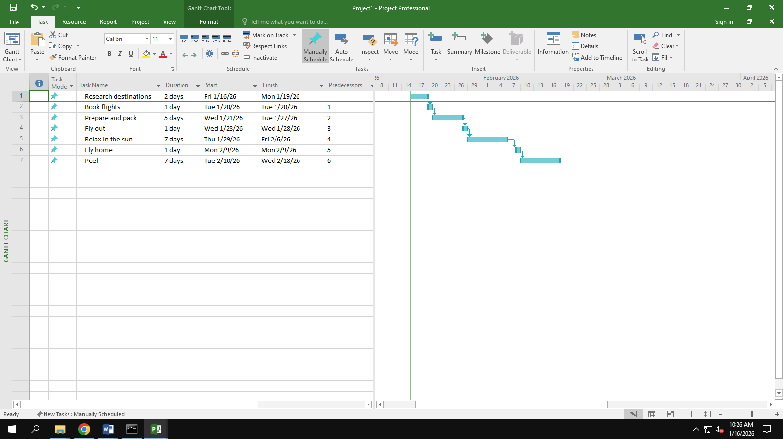

## 

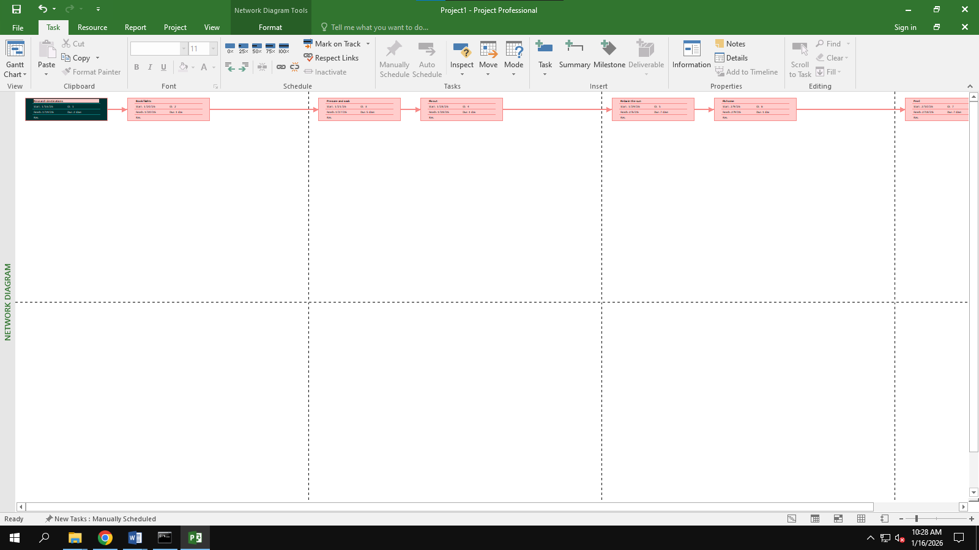

## Exercise 2: Setting duration

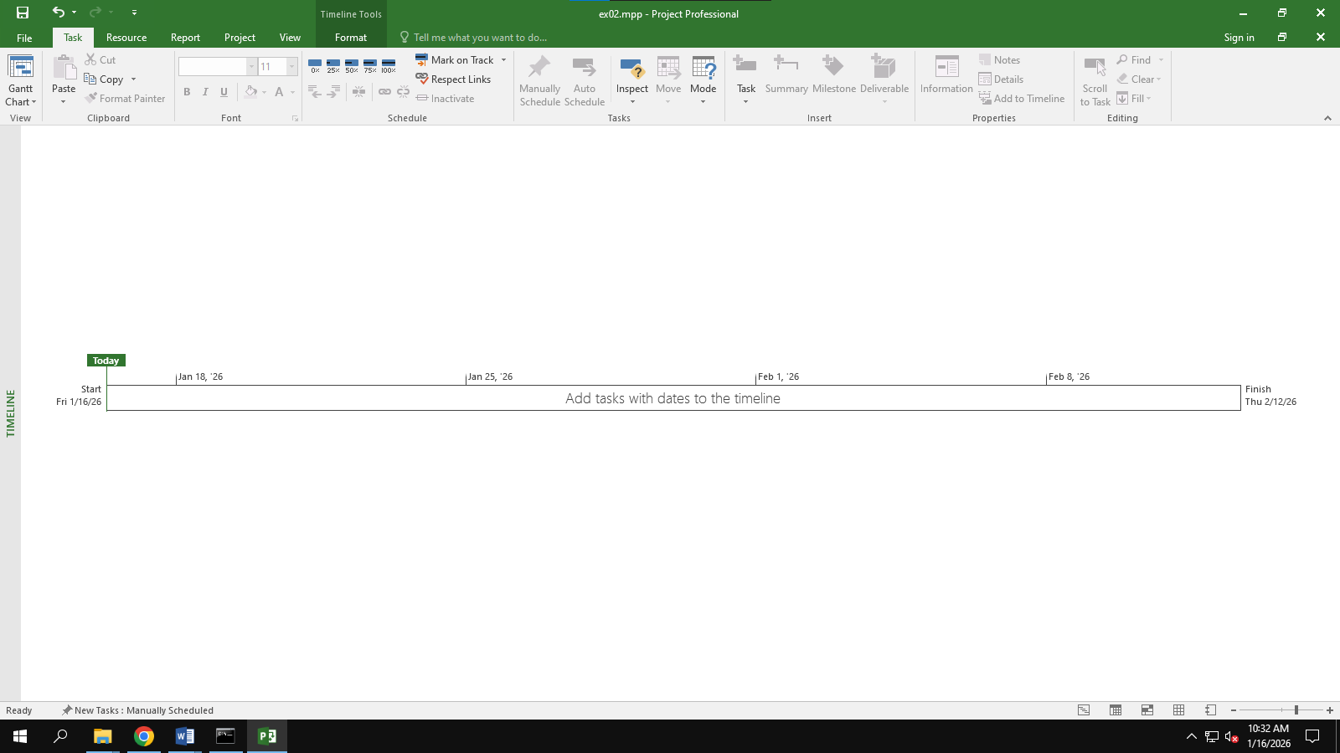

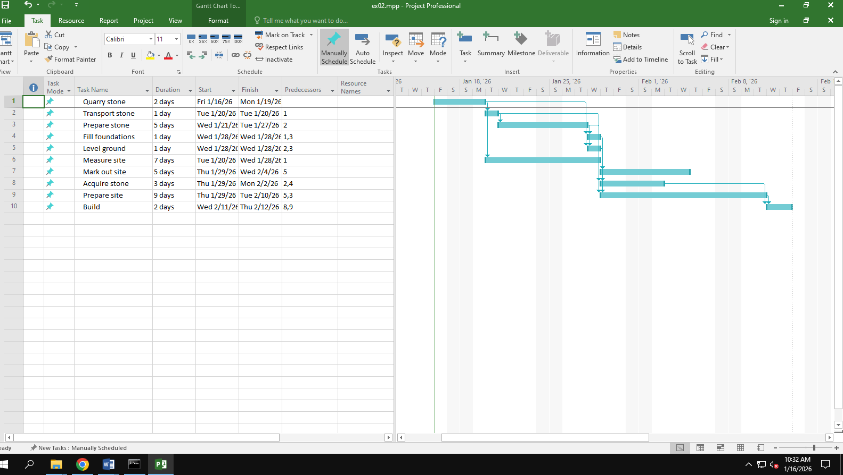

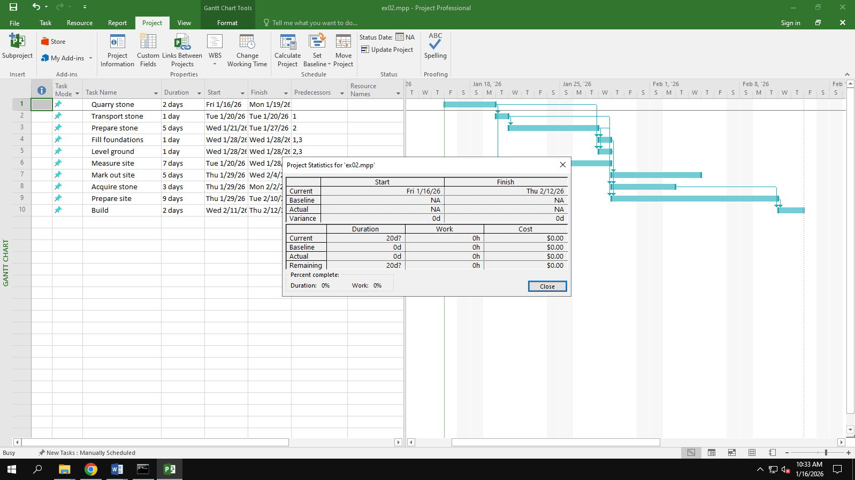

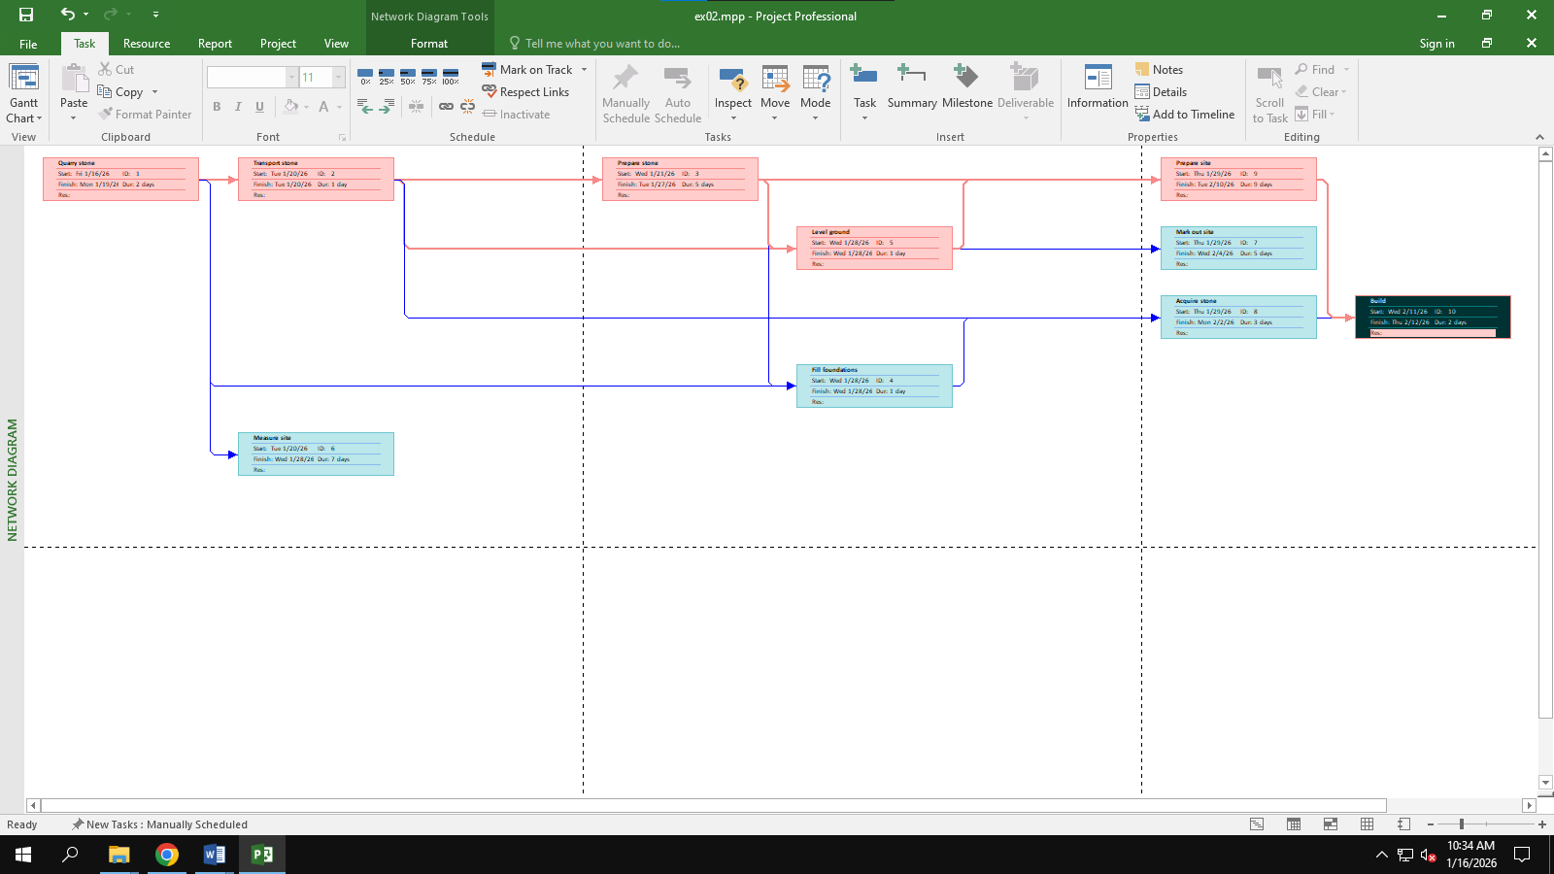

## Exercise 3: Creating phases

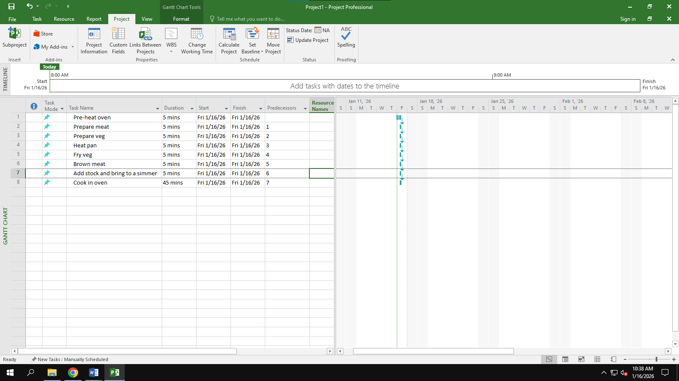

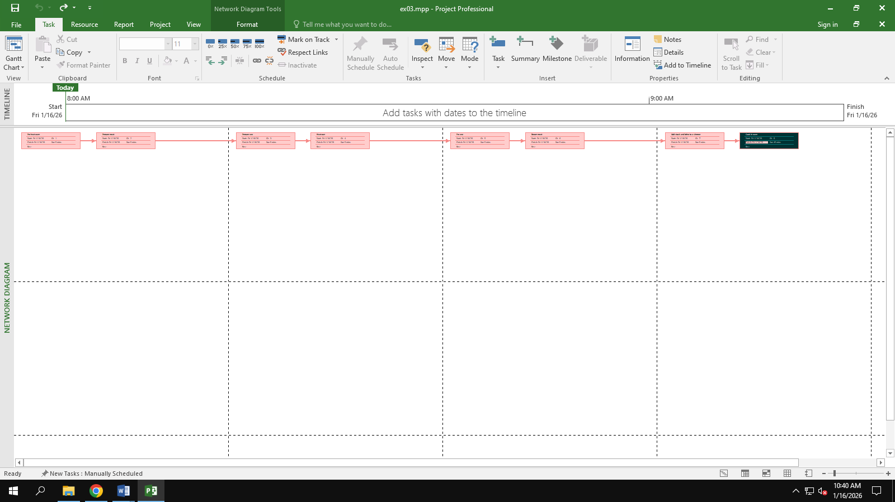

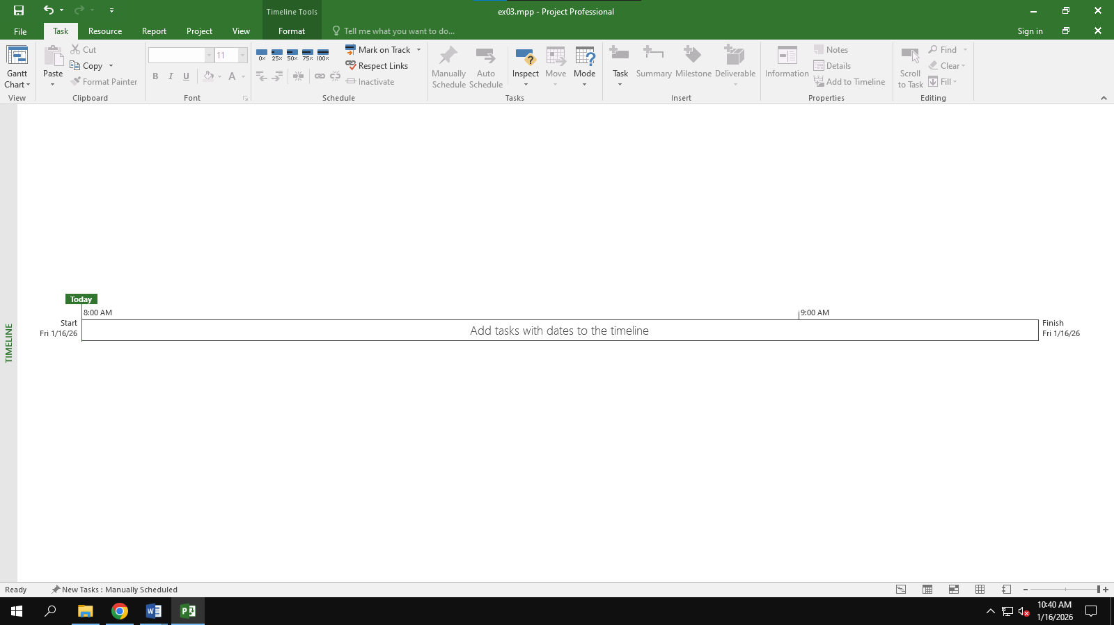

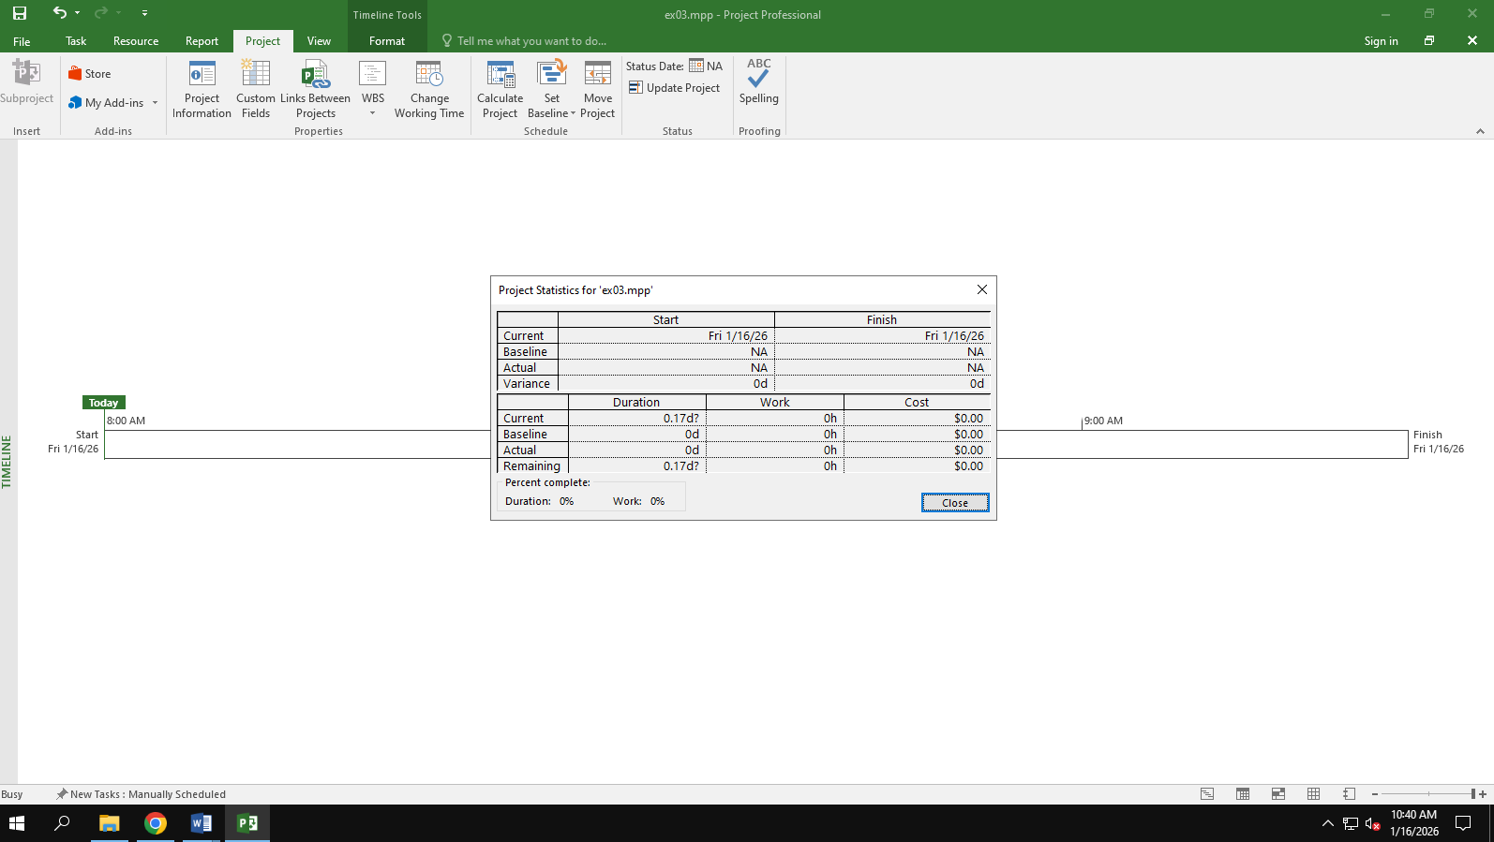

## Exercise 4: Noah - Linking

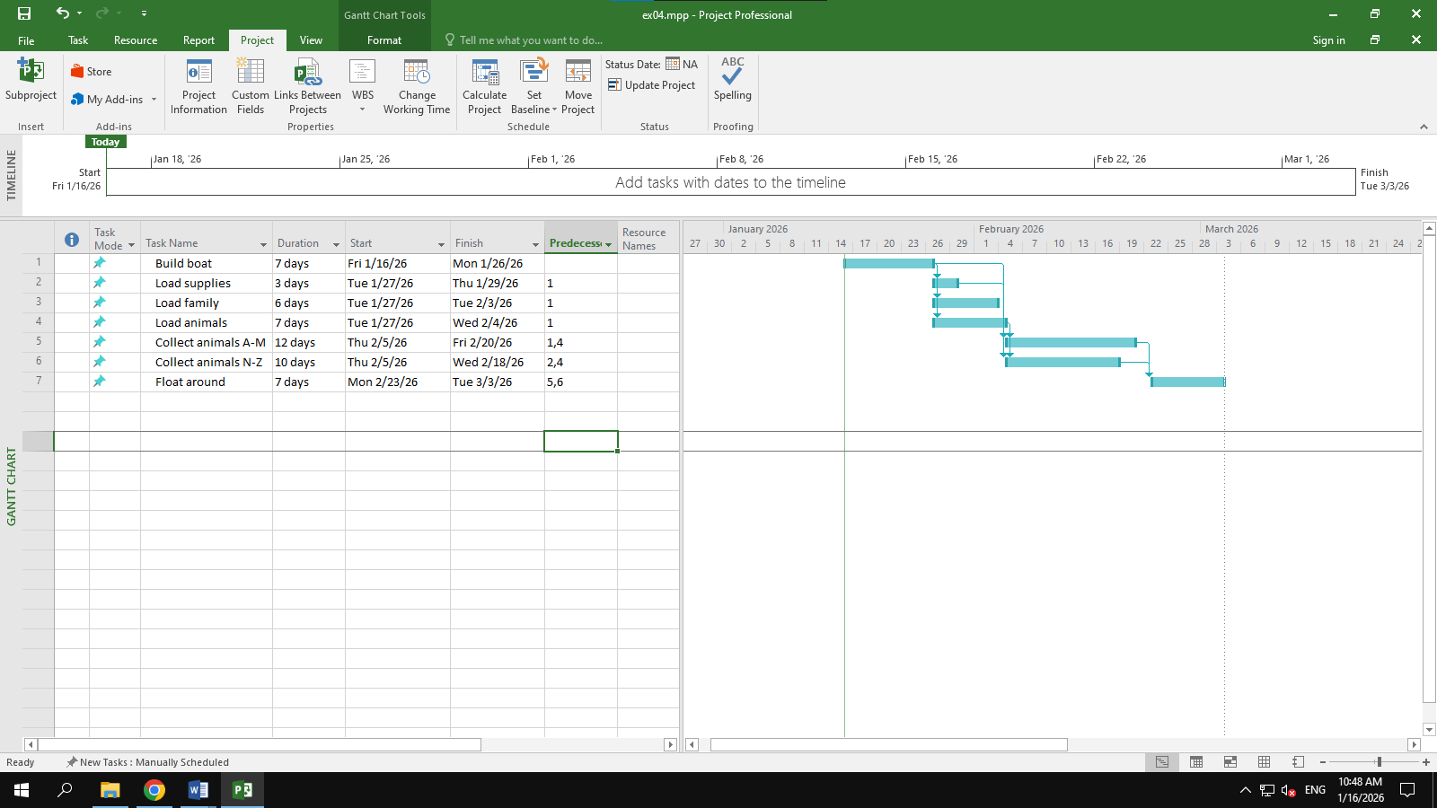

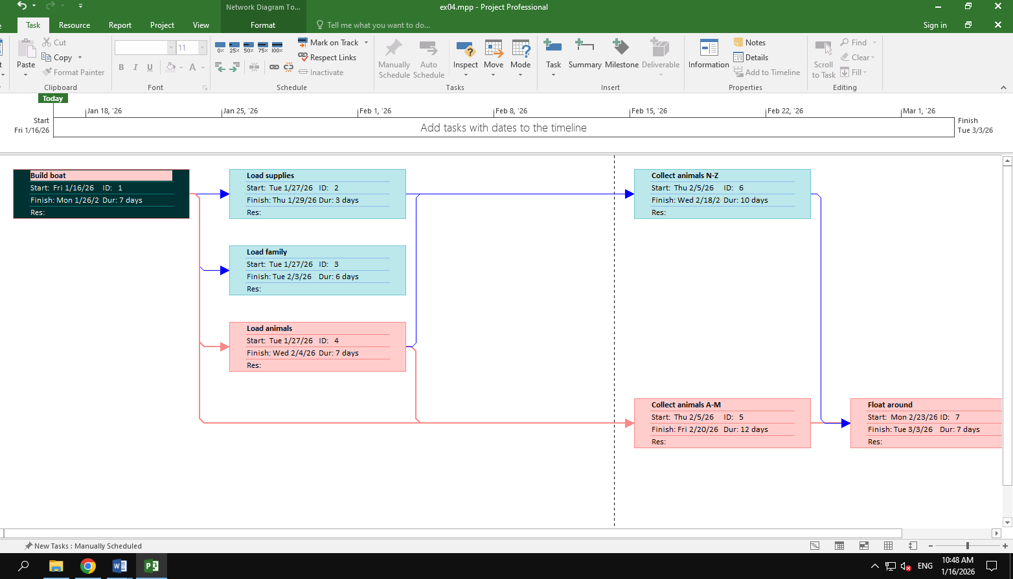

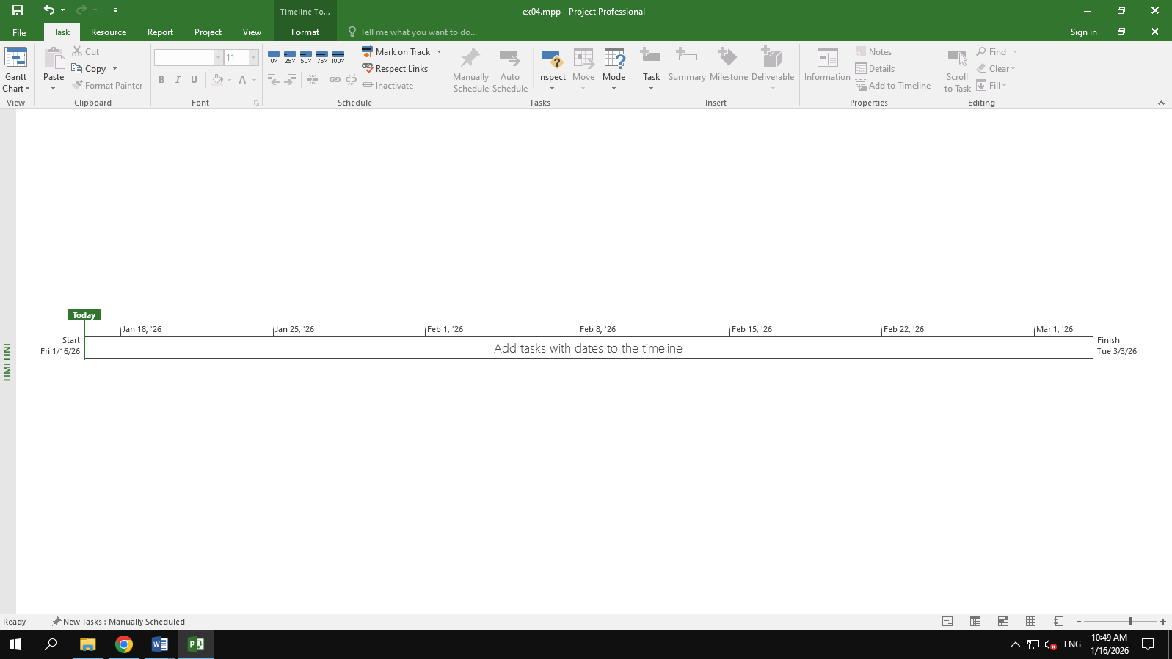

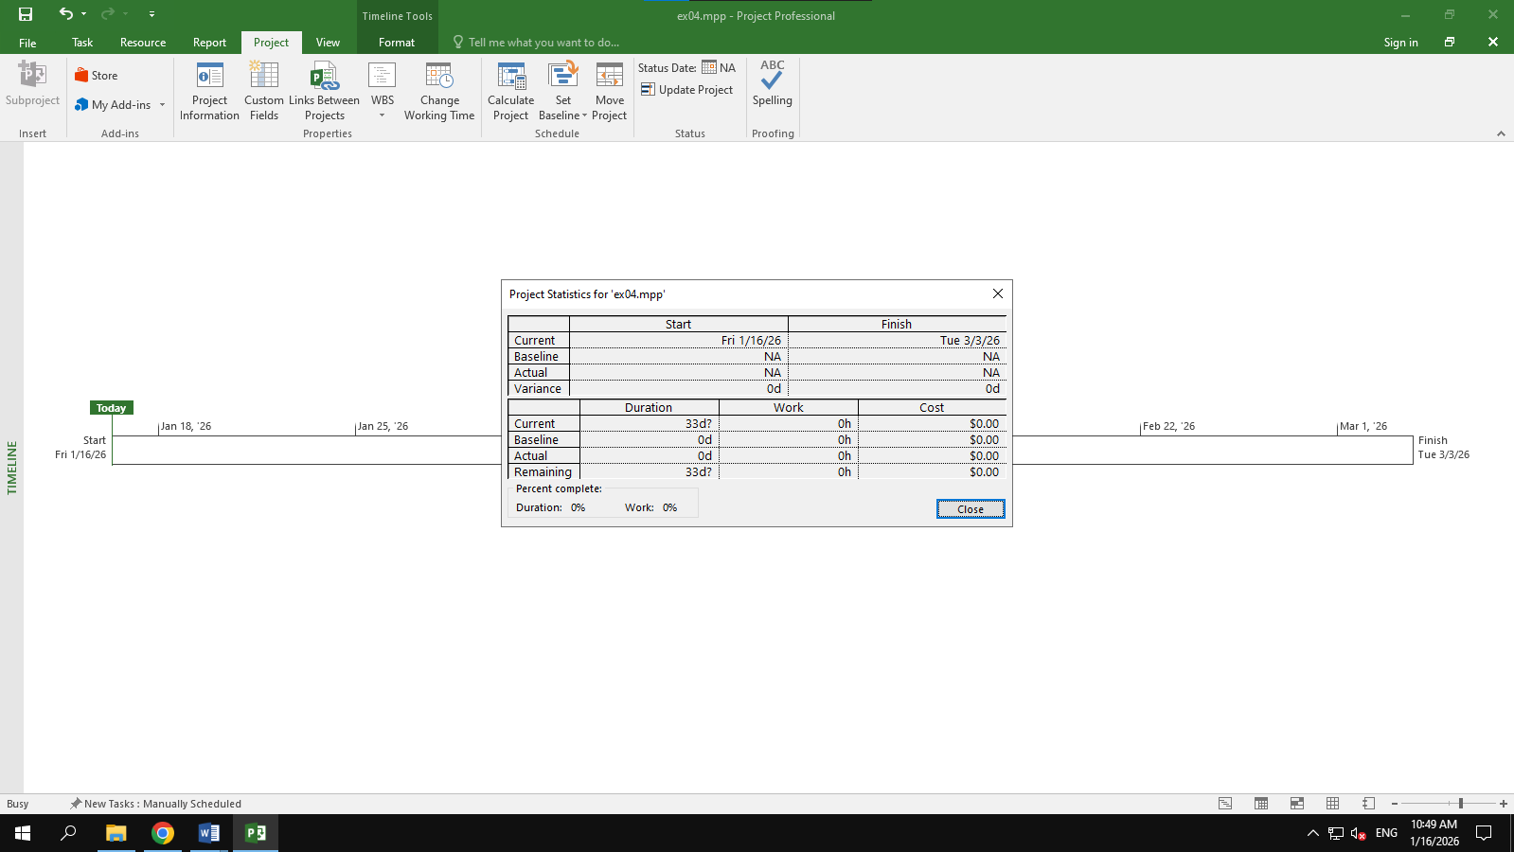

## Exercise 5: Pyramid - Multi level grouping

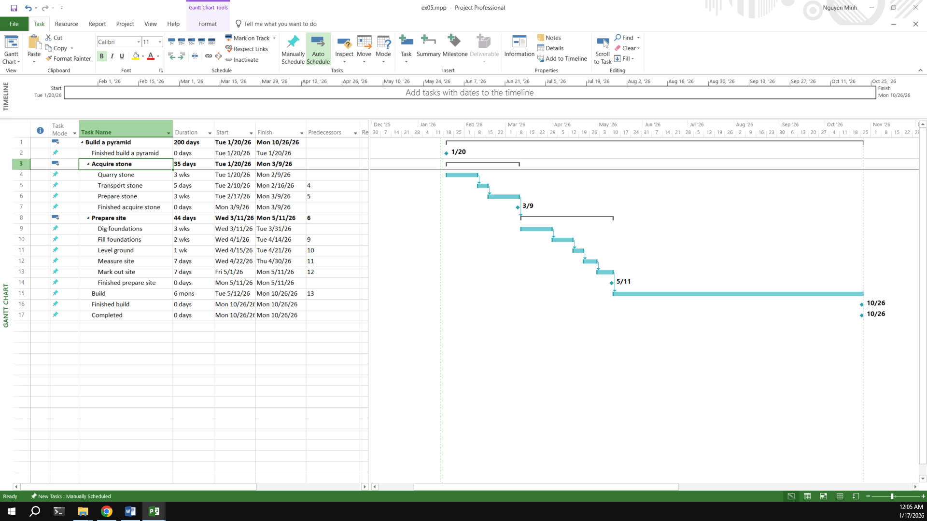

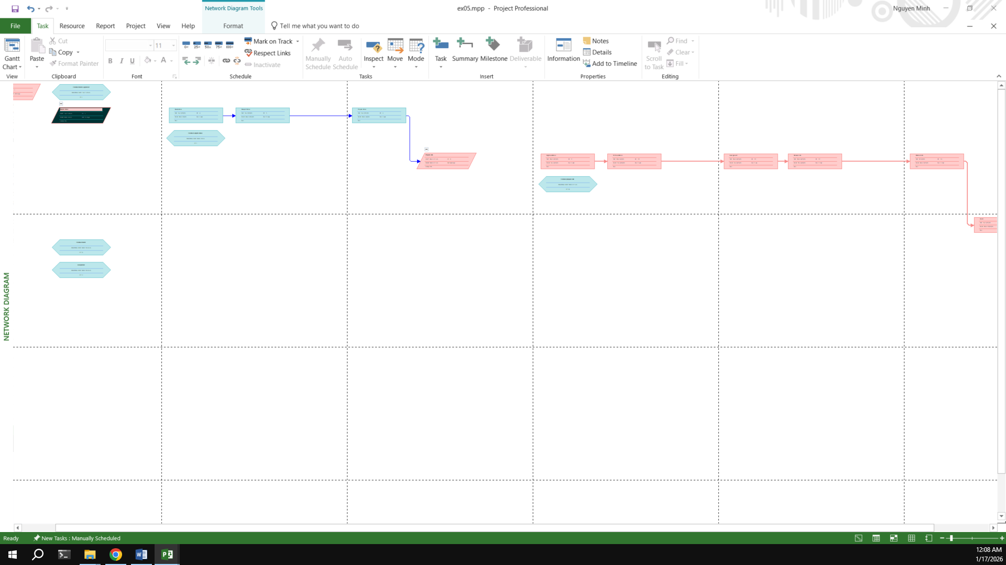

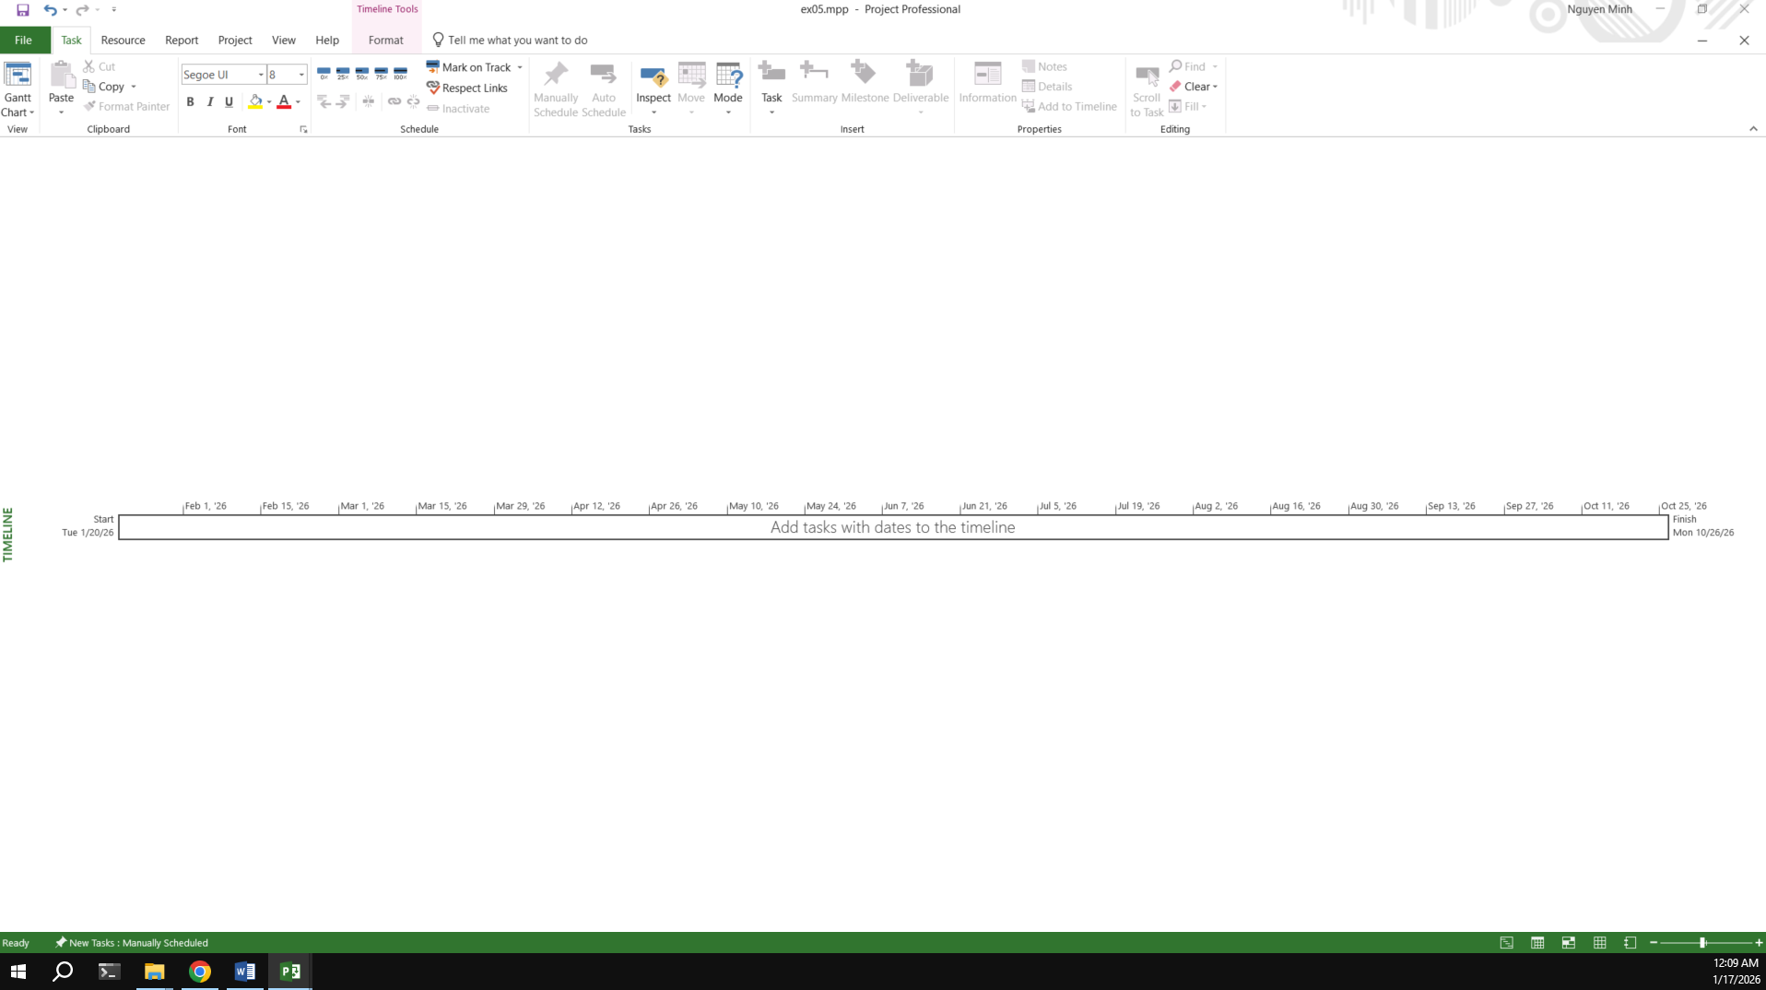

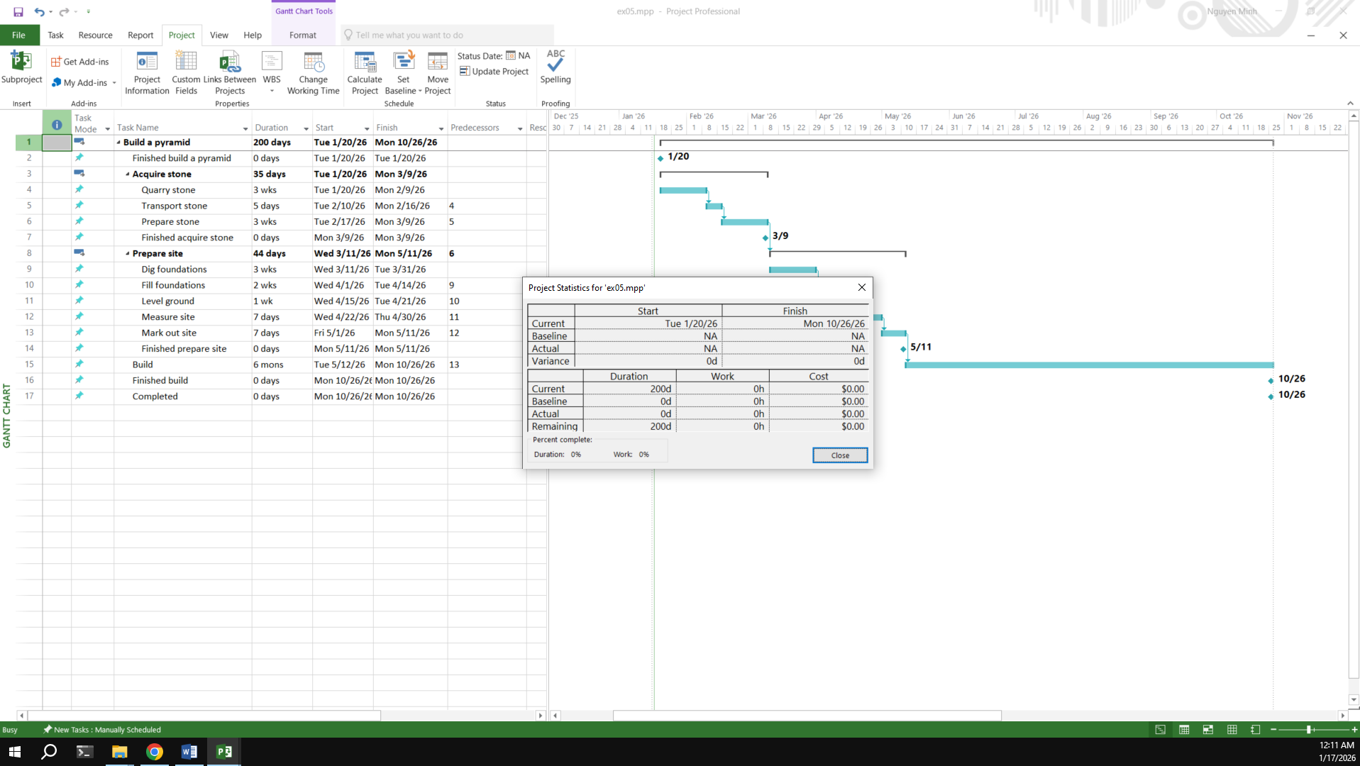

## Exercise 6: Creating a plan for Staff Training

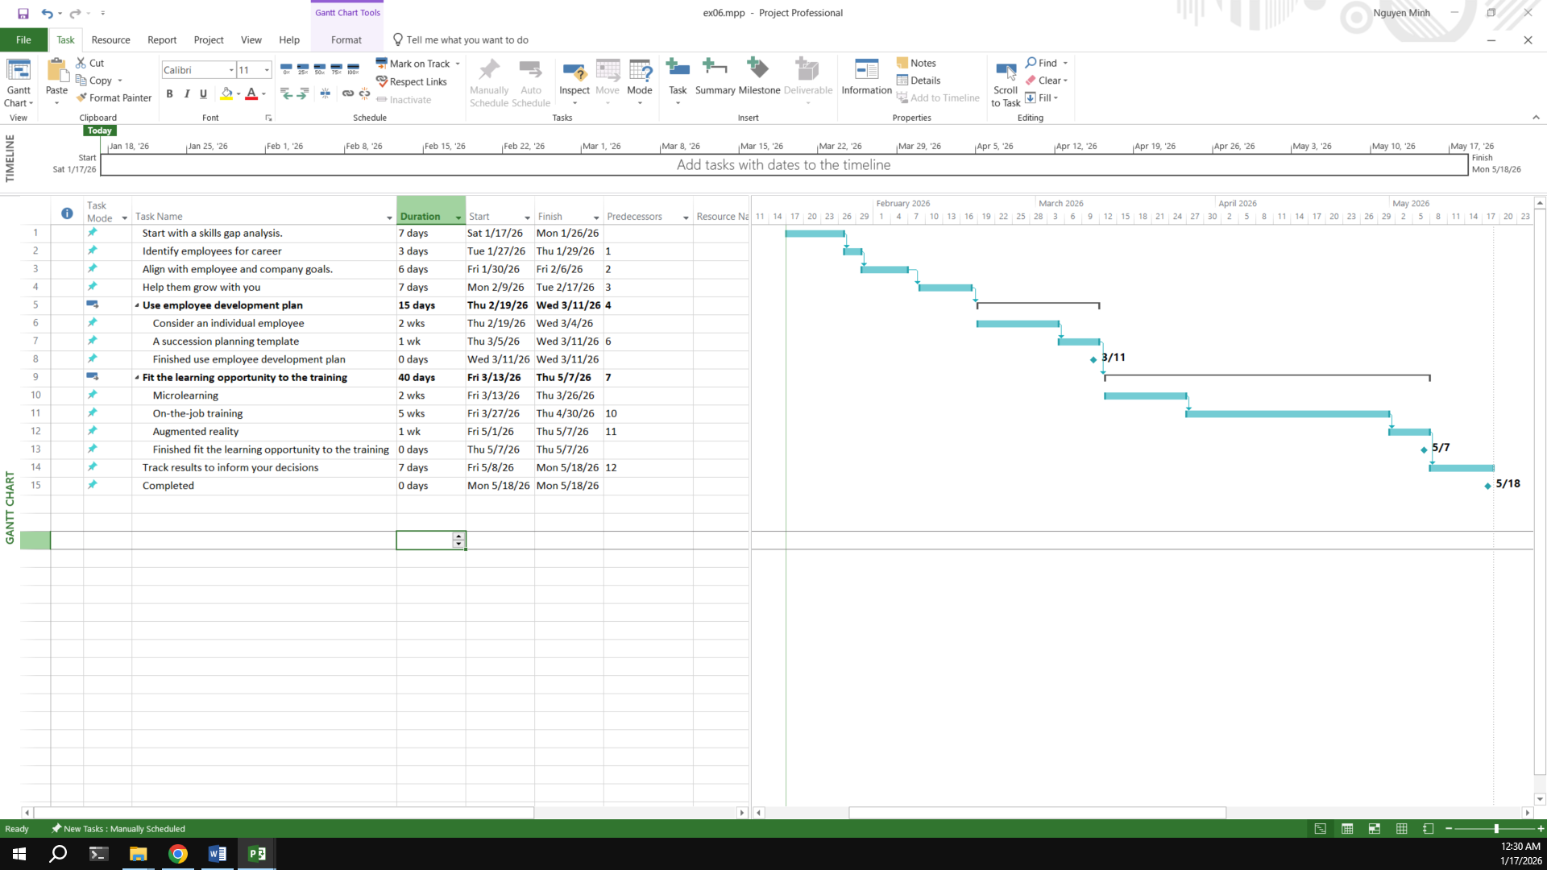

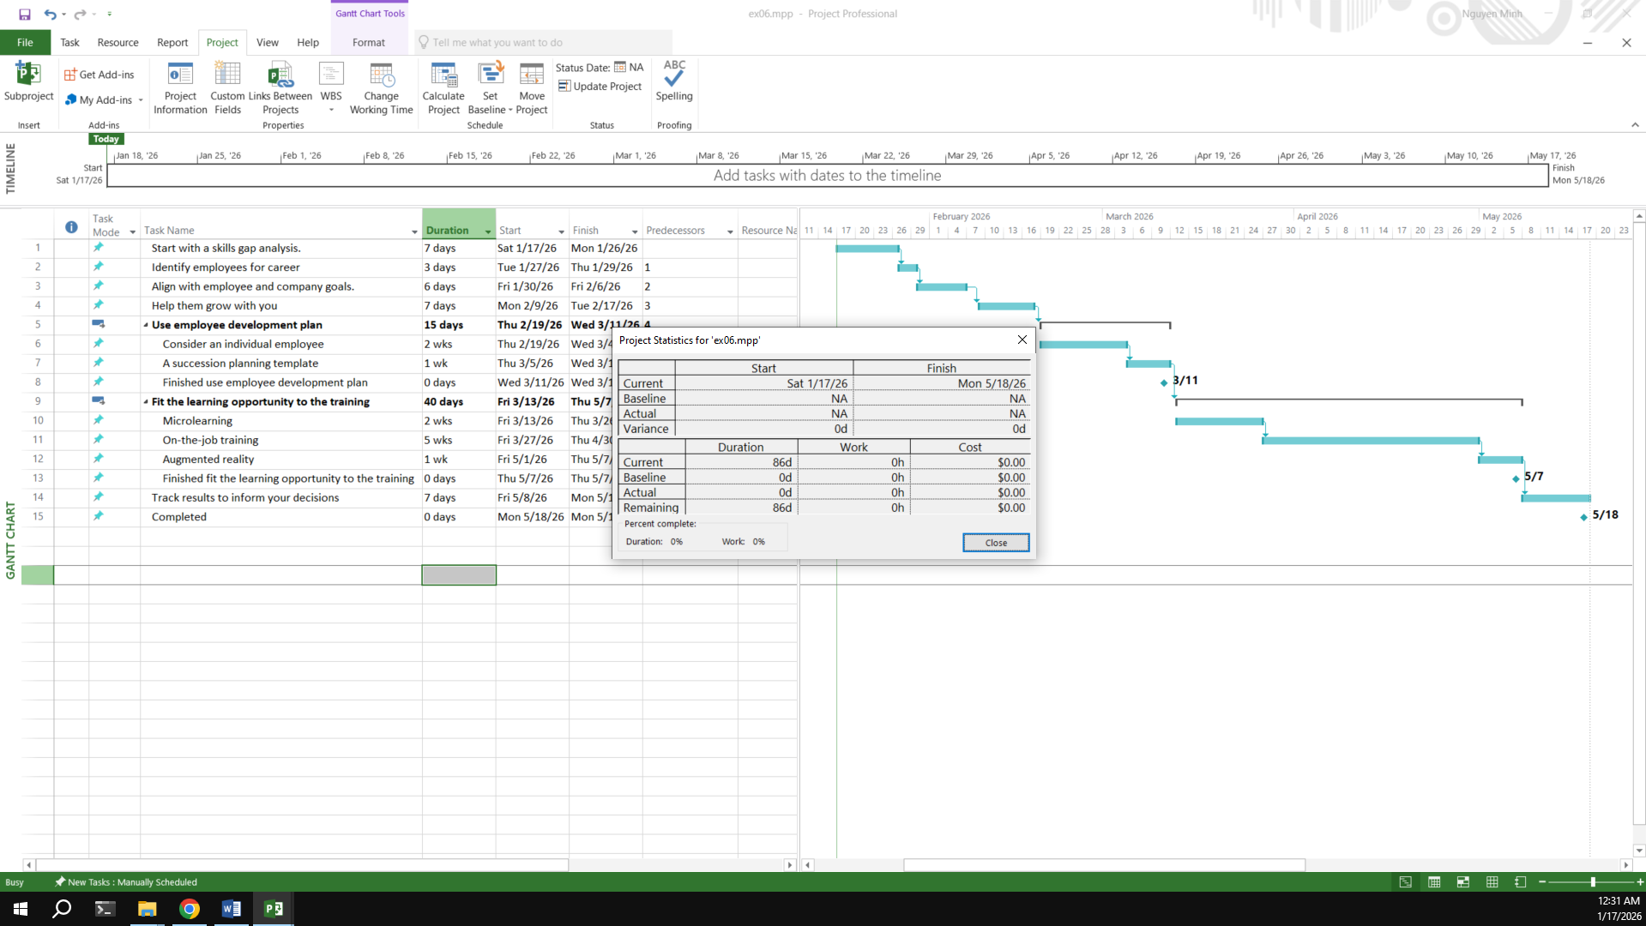

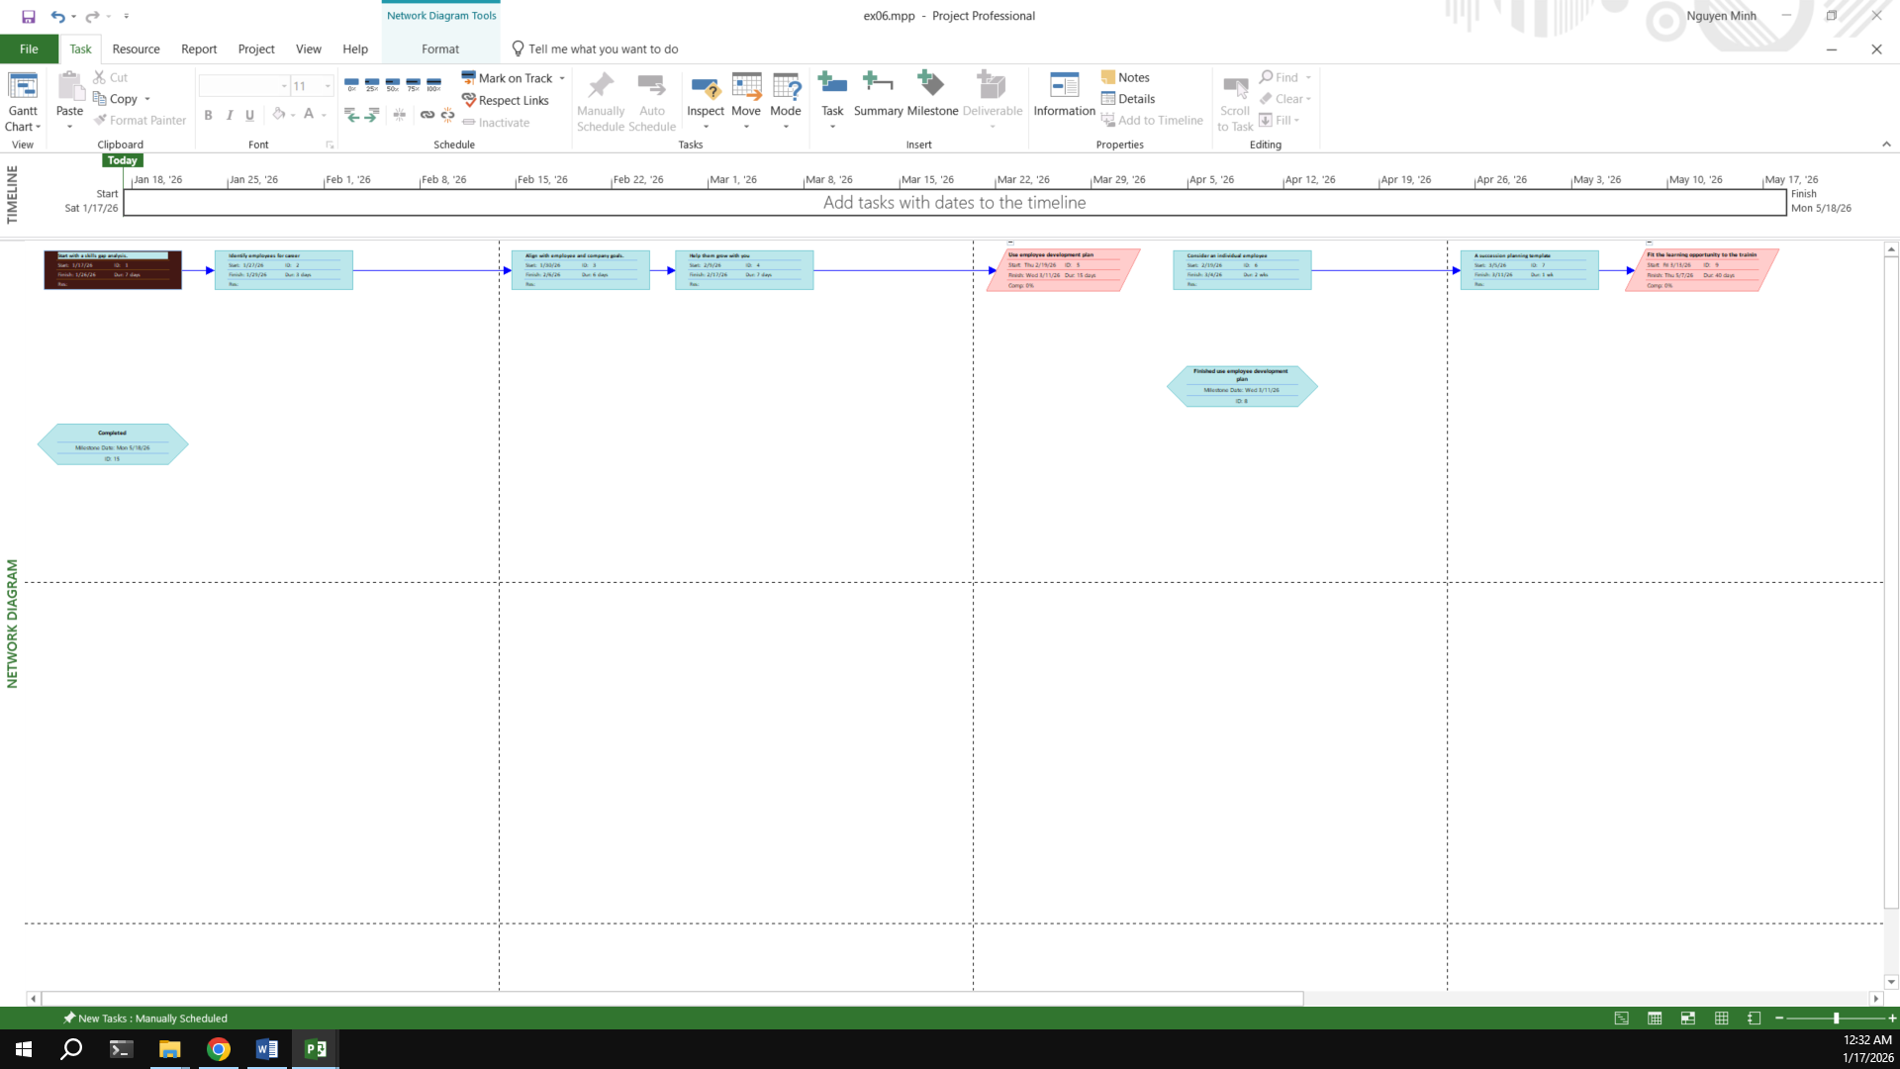

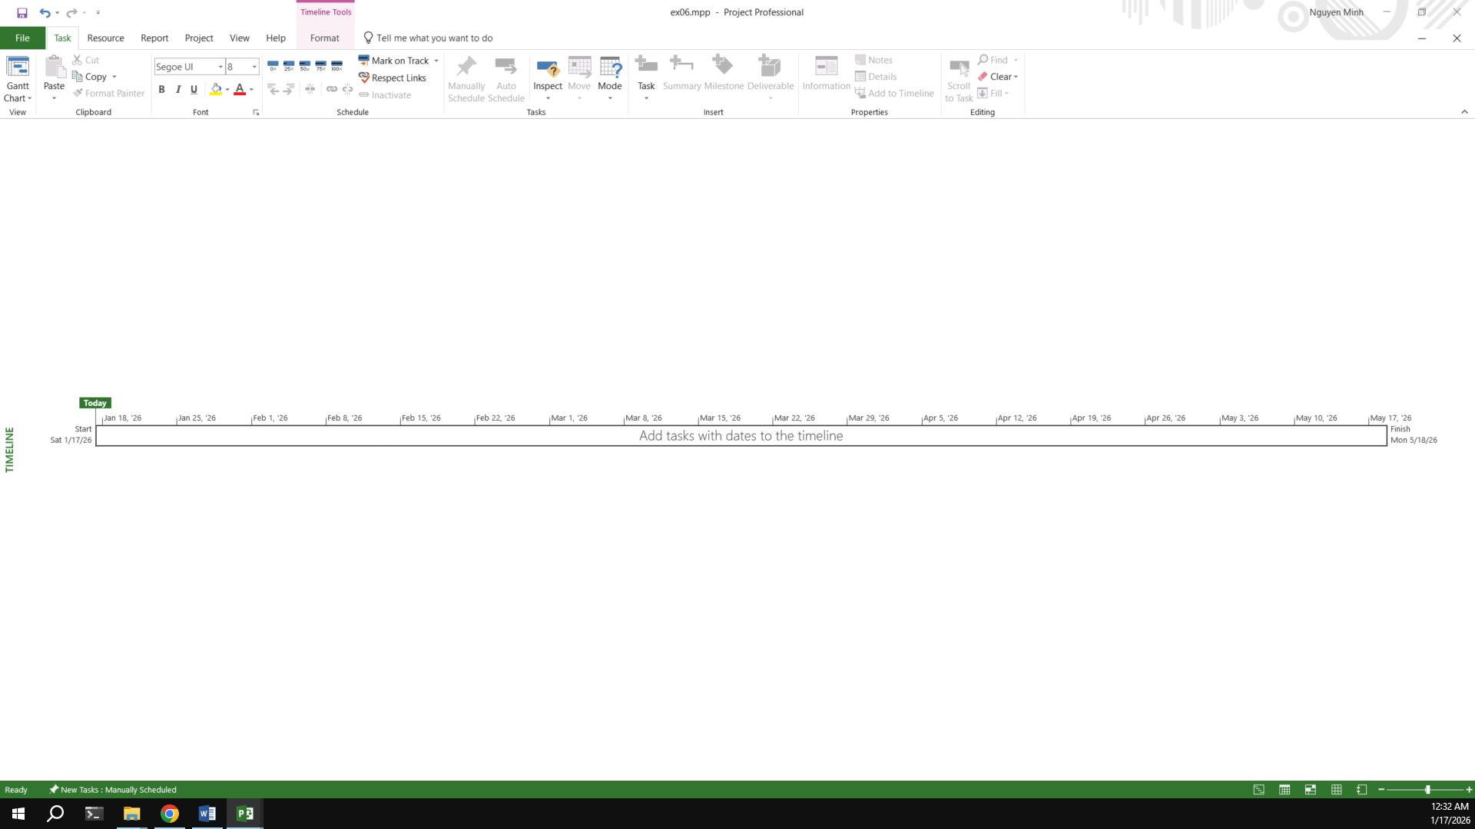

## Exercise 7: Recurring Tasks

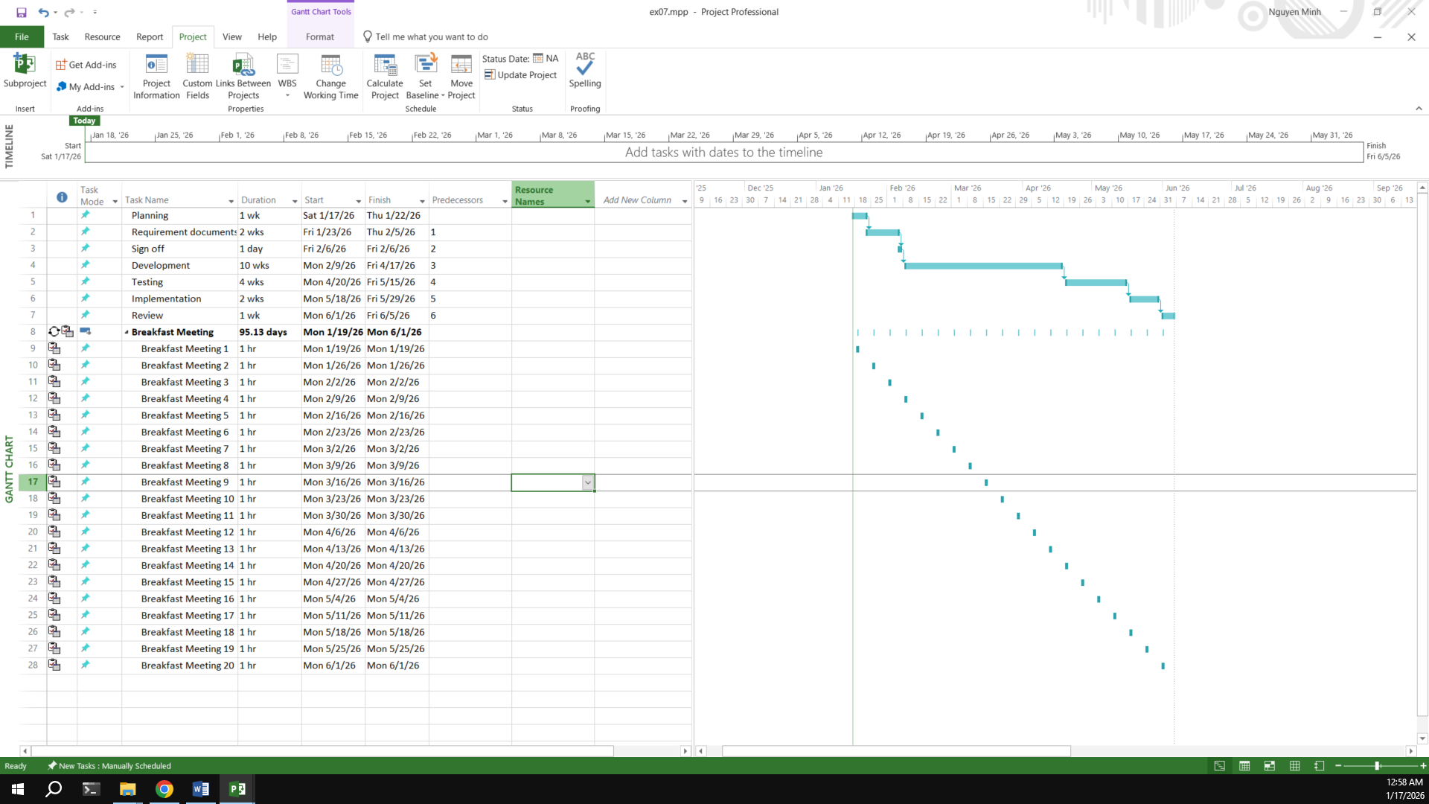

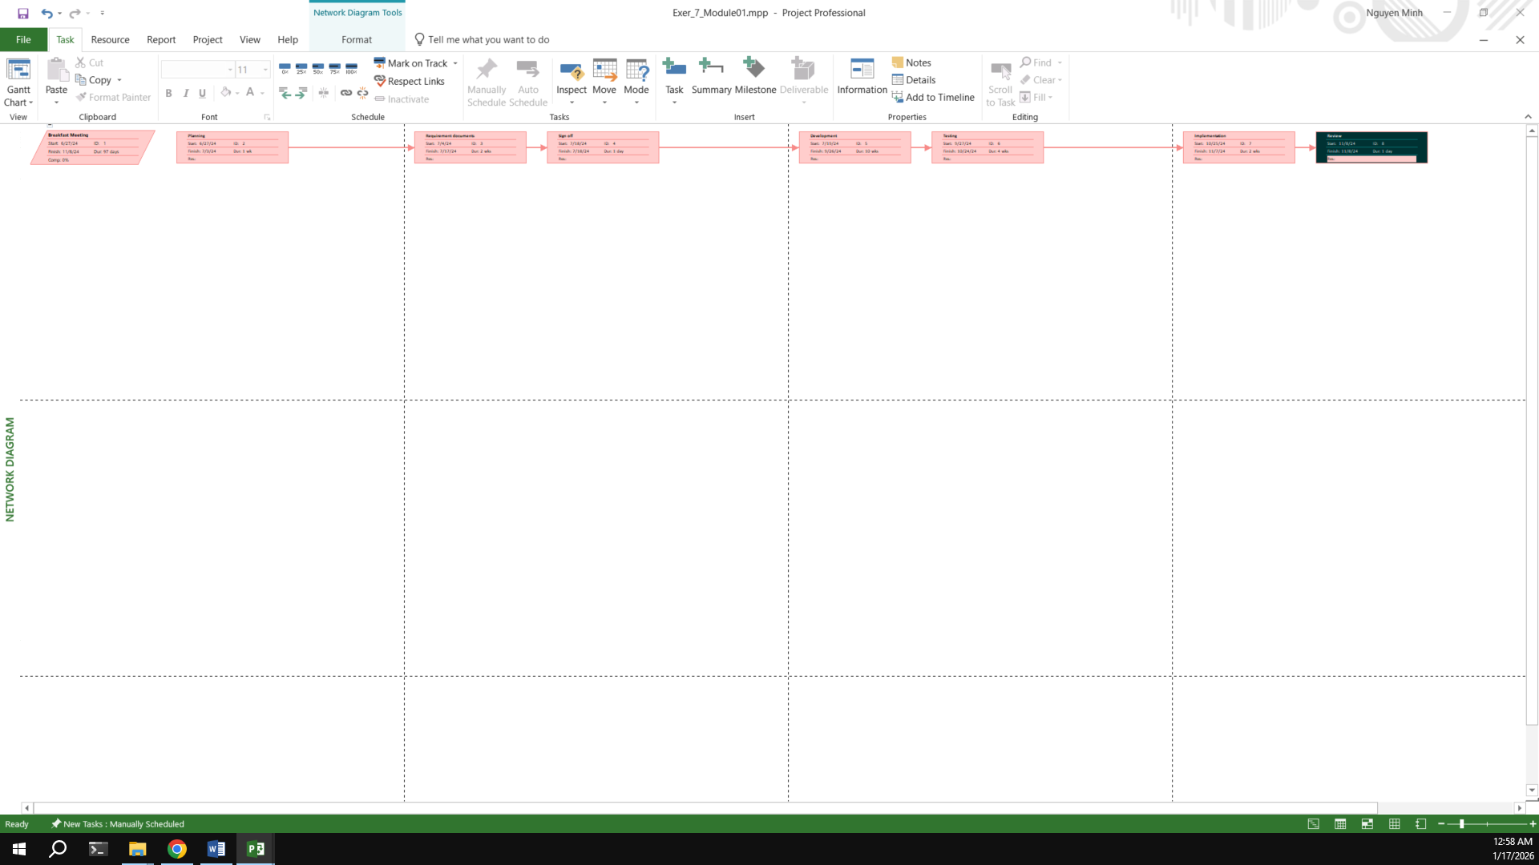

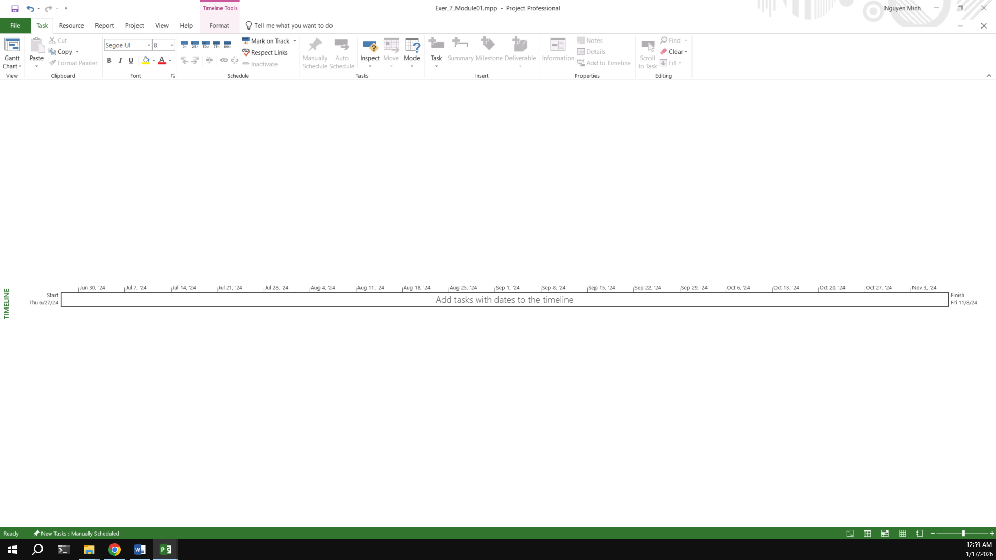

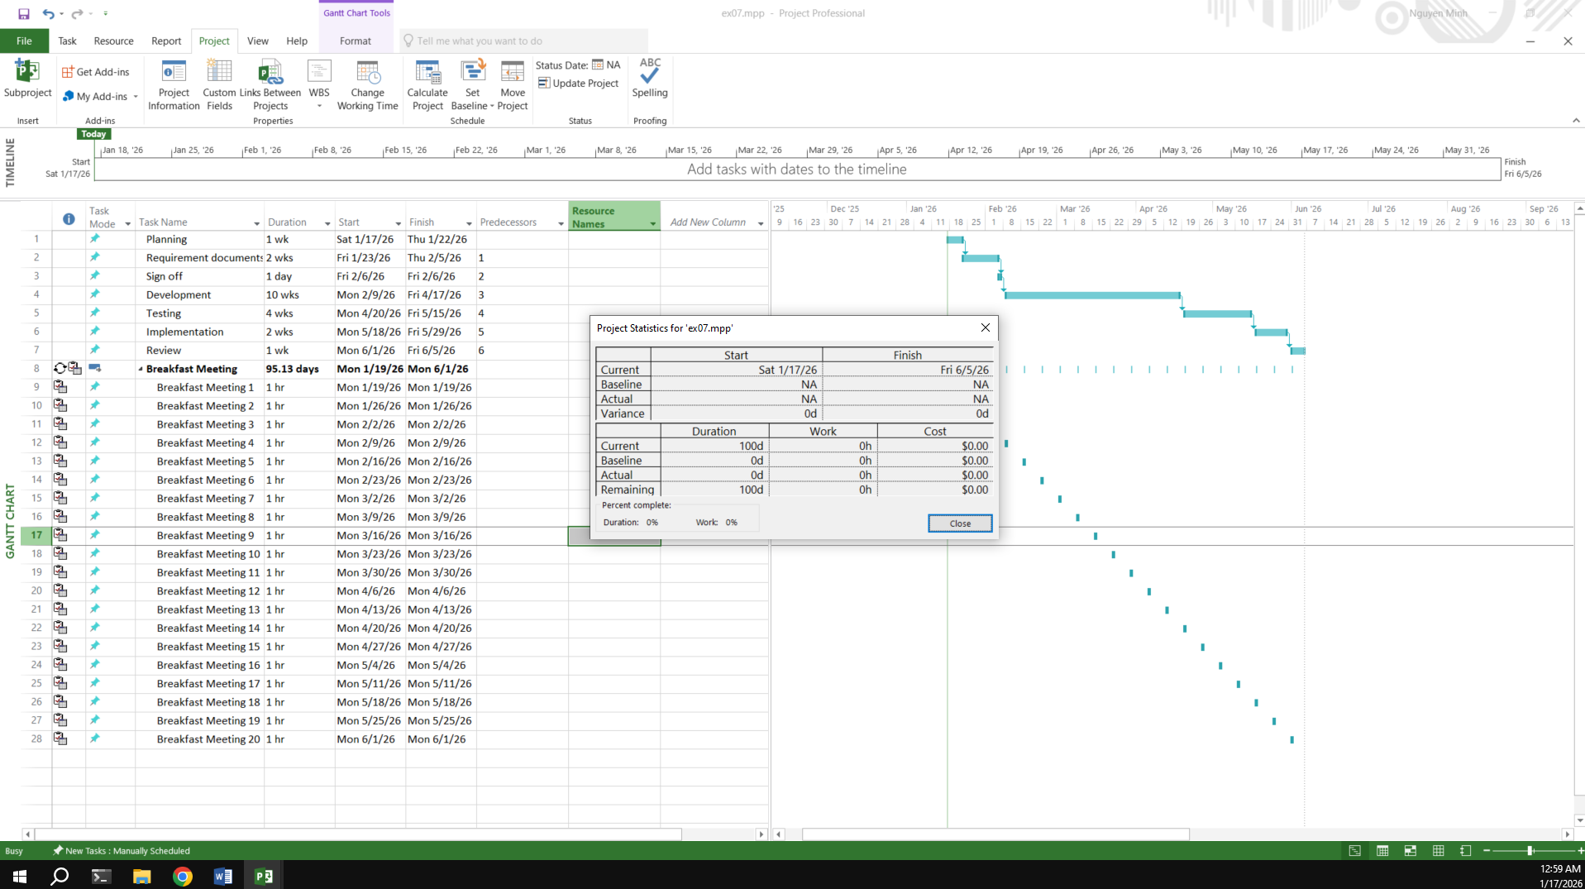

## Exercise 8: Travelling – tasks calendar

Travelling – task calendar You intend to travel from HCM to Kuala Lumpur, Bangkok and then, come back to HCM. Creating a plan for your trip.

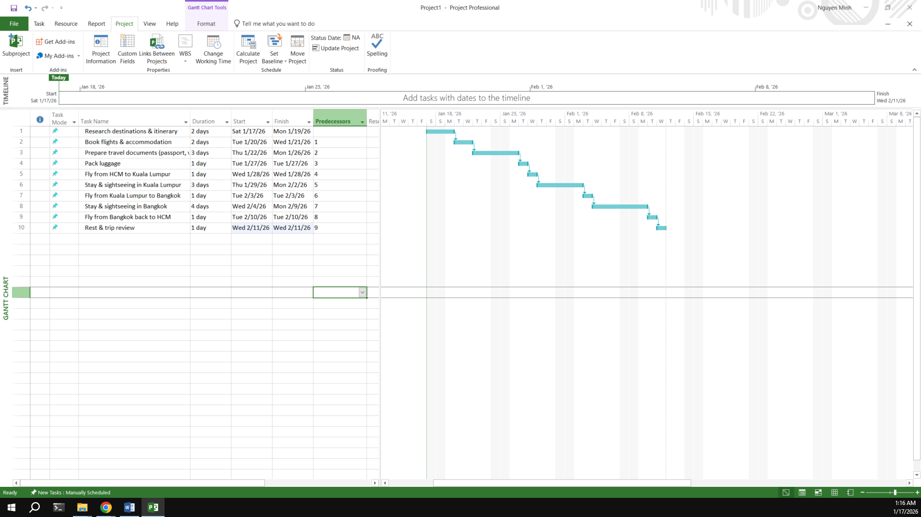

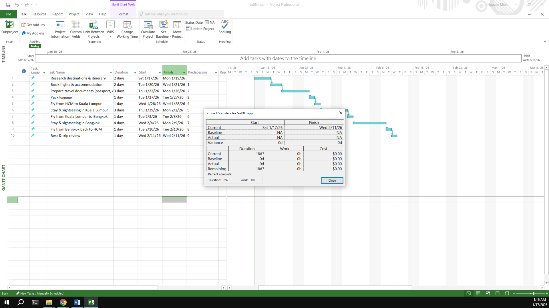

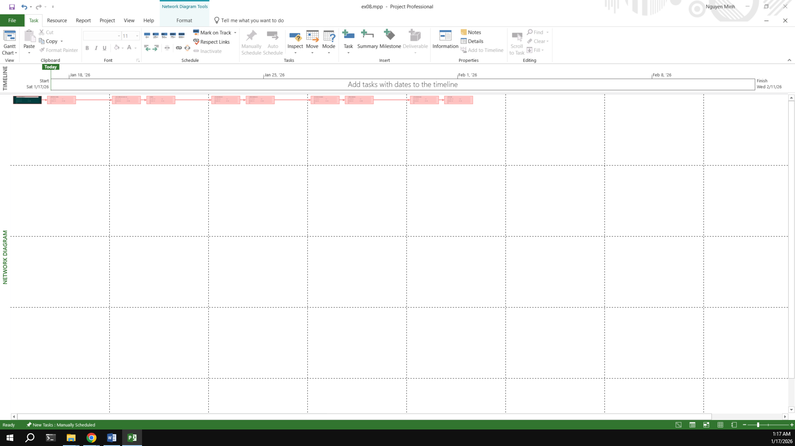

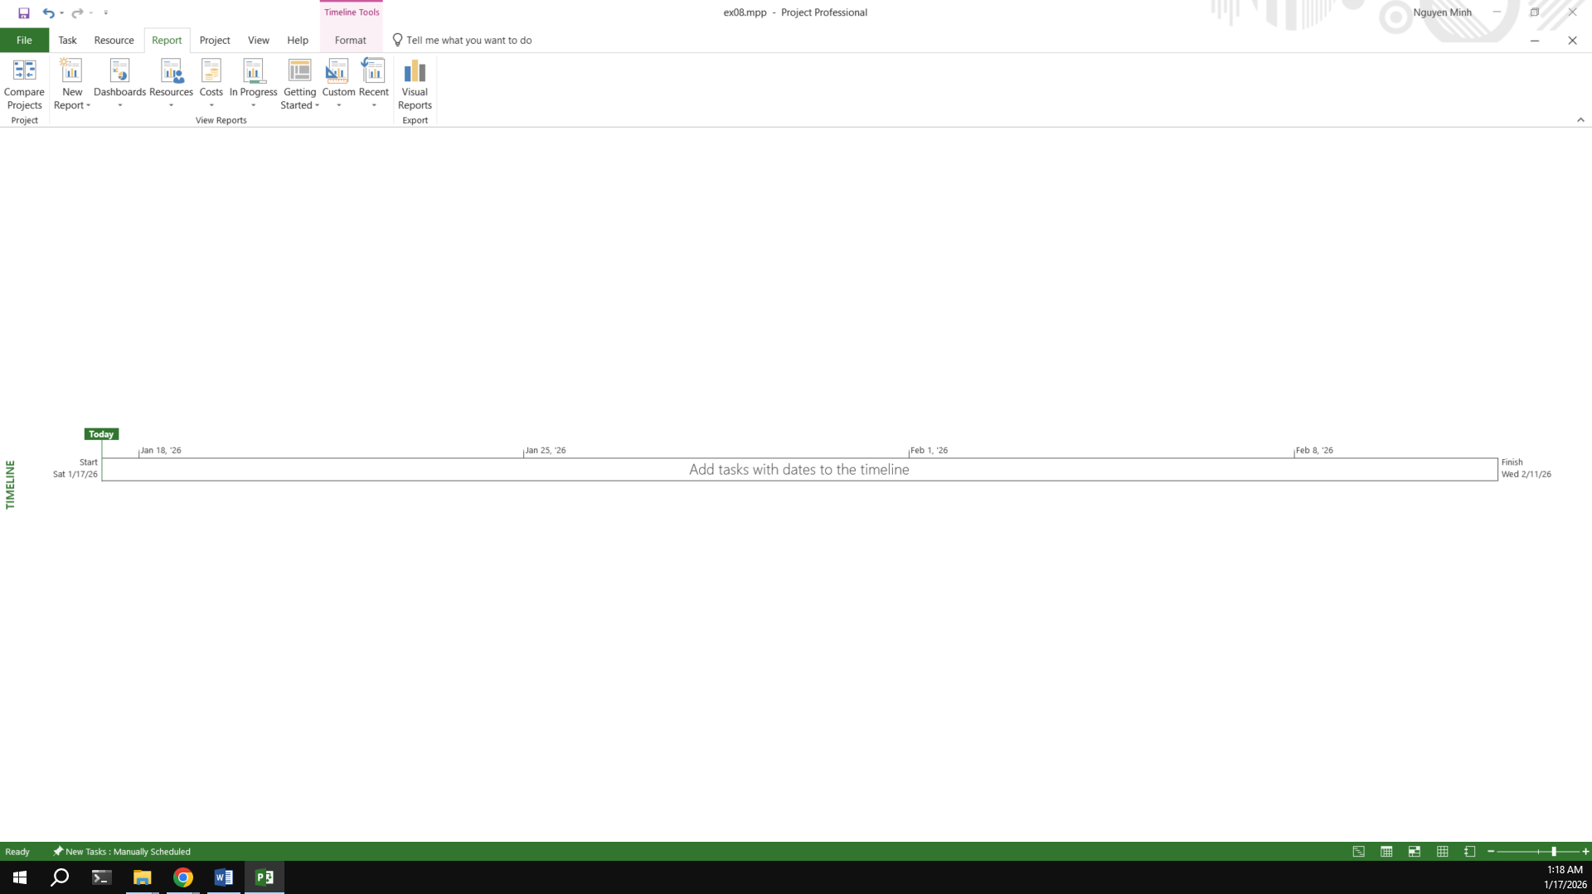

**- End Module 01 -**

# Module 2:

## Exercise 1:

**Part Time - creating new calendar   
Open project file Ex2 (Module 1), Use the Project Information dialog box to:**

A part-time worker will be used on this project. Go to the Change Working Time dialog box and create a new copy of the Standard calendar, calling it "Part Time".

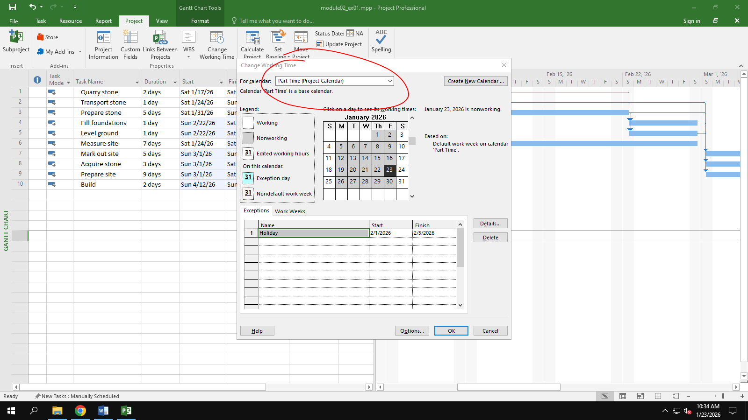

Update the working time of your new calendar so that:   
¬ Mondays to Fridays are nonworking time   
¬ The remaining 2 weekdays have working time of 10:00 to 16:00 ( no breaks)

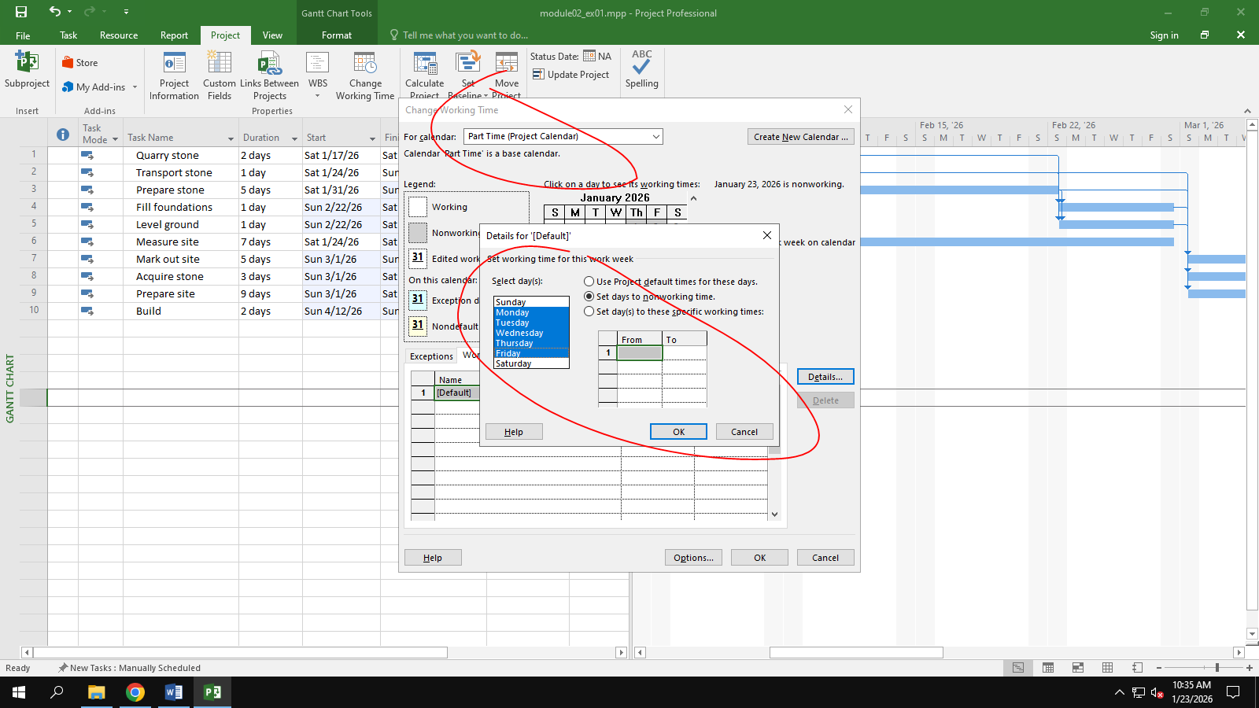

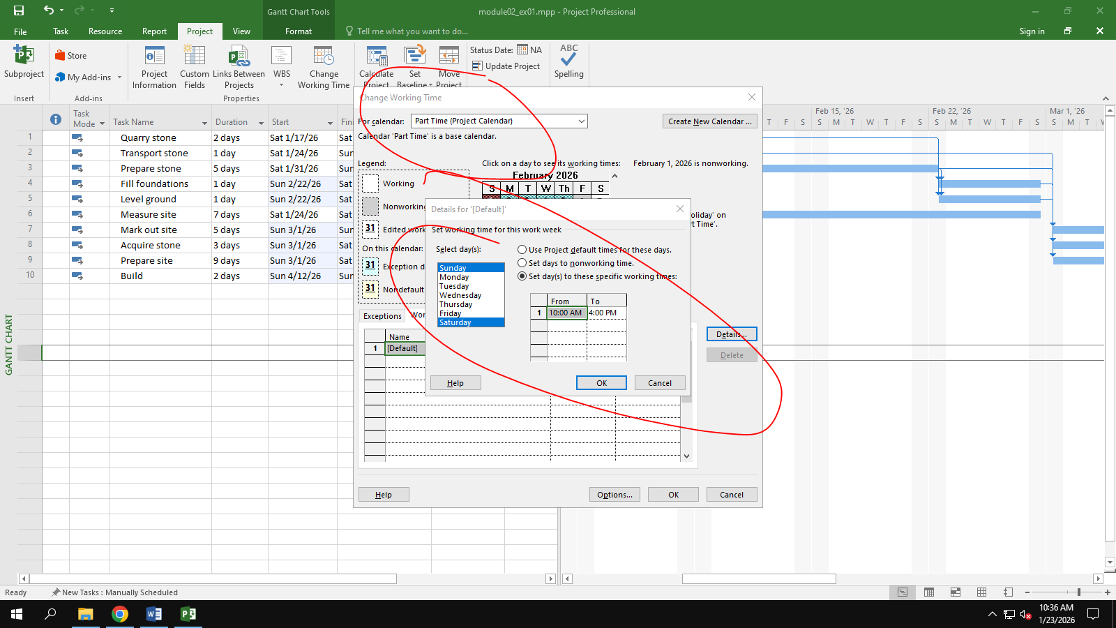

The Part time has also booked a holiday from 1st to Feb 5th . Create an Exception to their calendar with a Holiday name and these days as nonworking

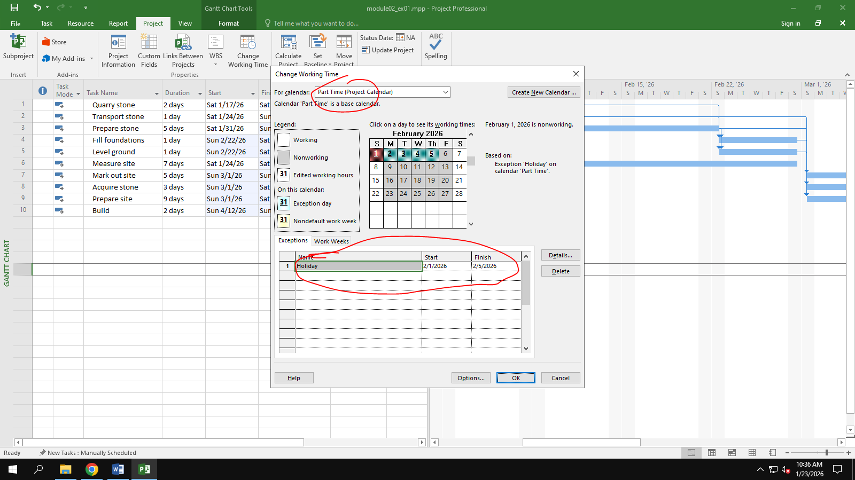

Display the Project Information.

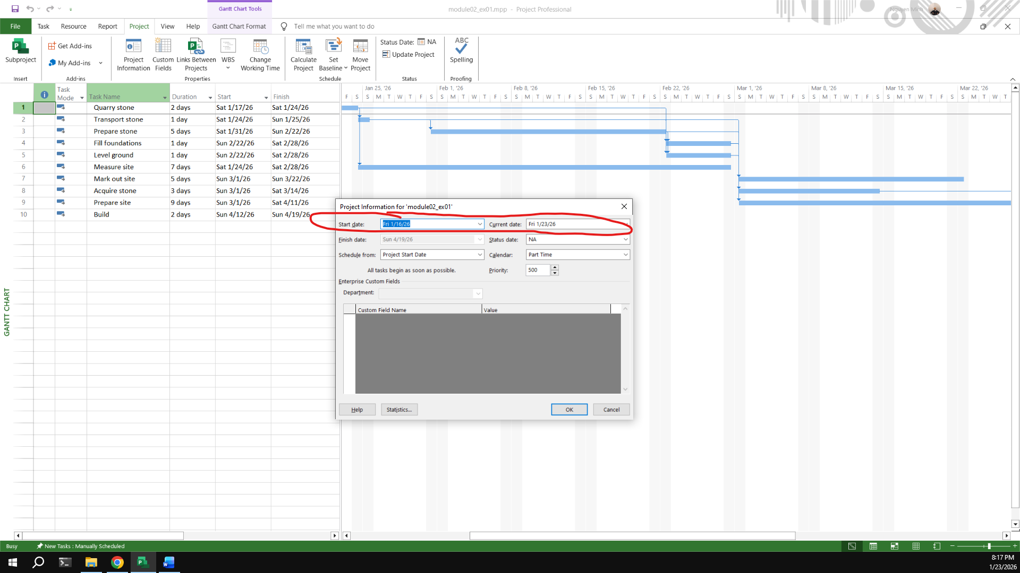

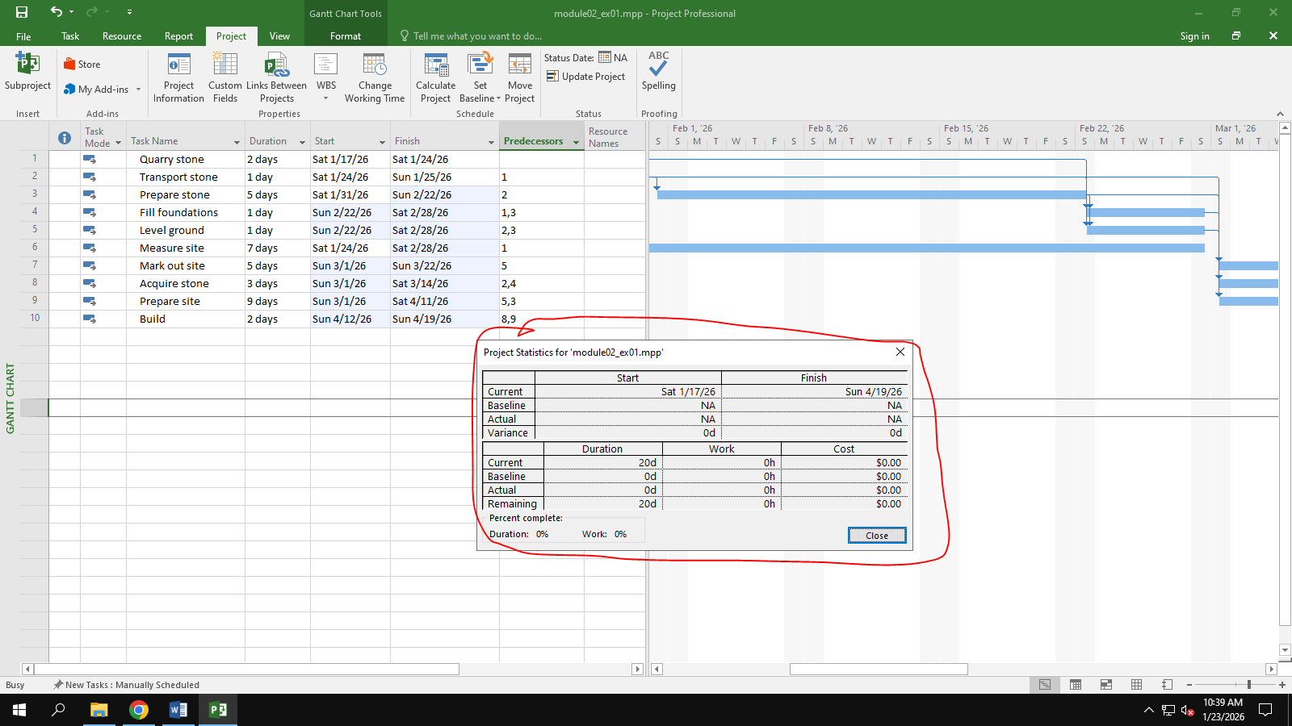

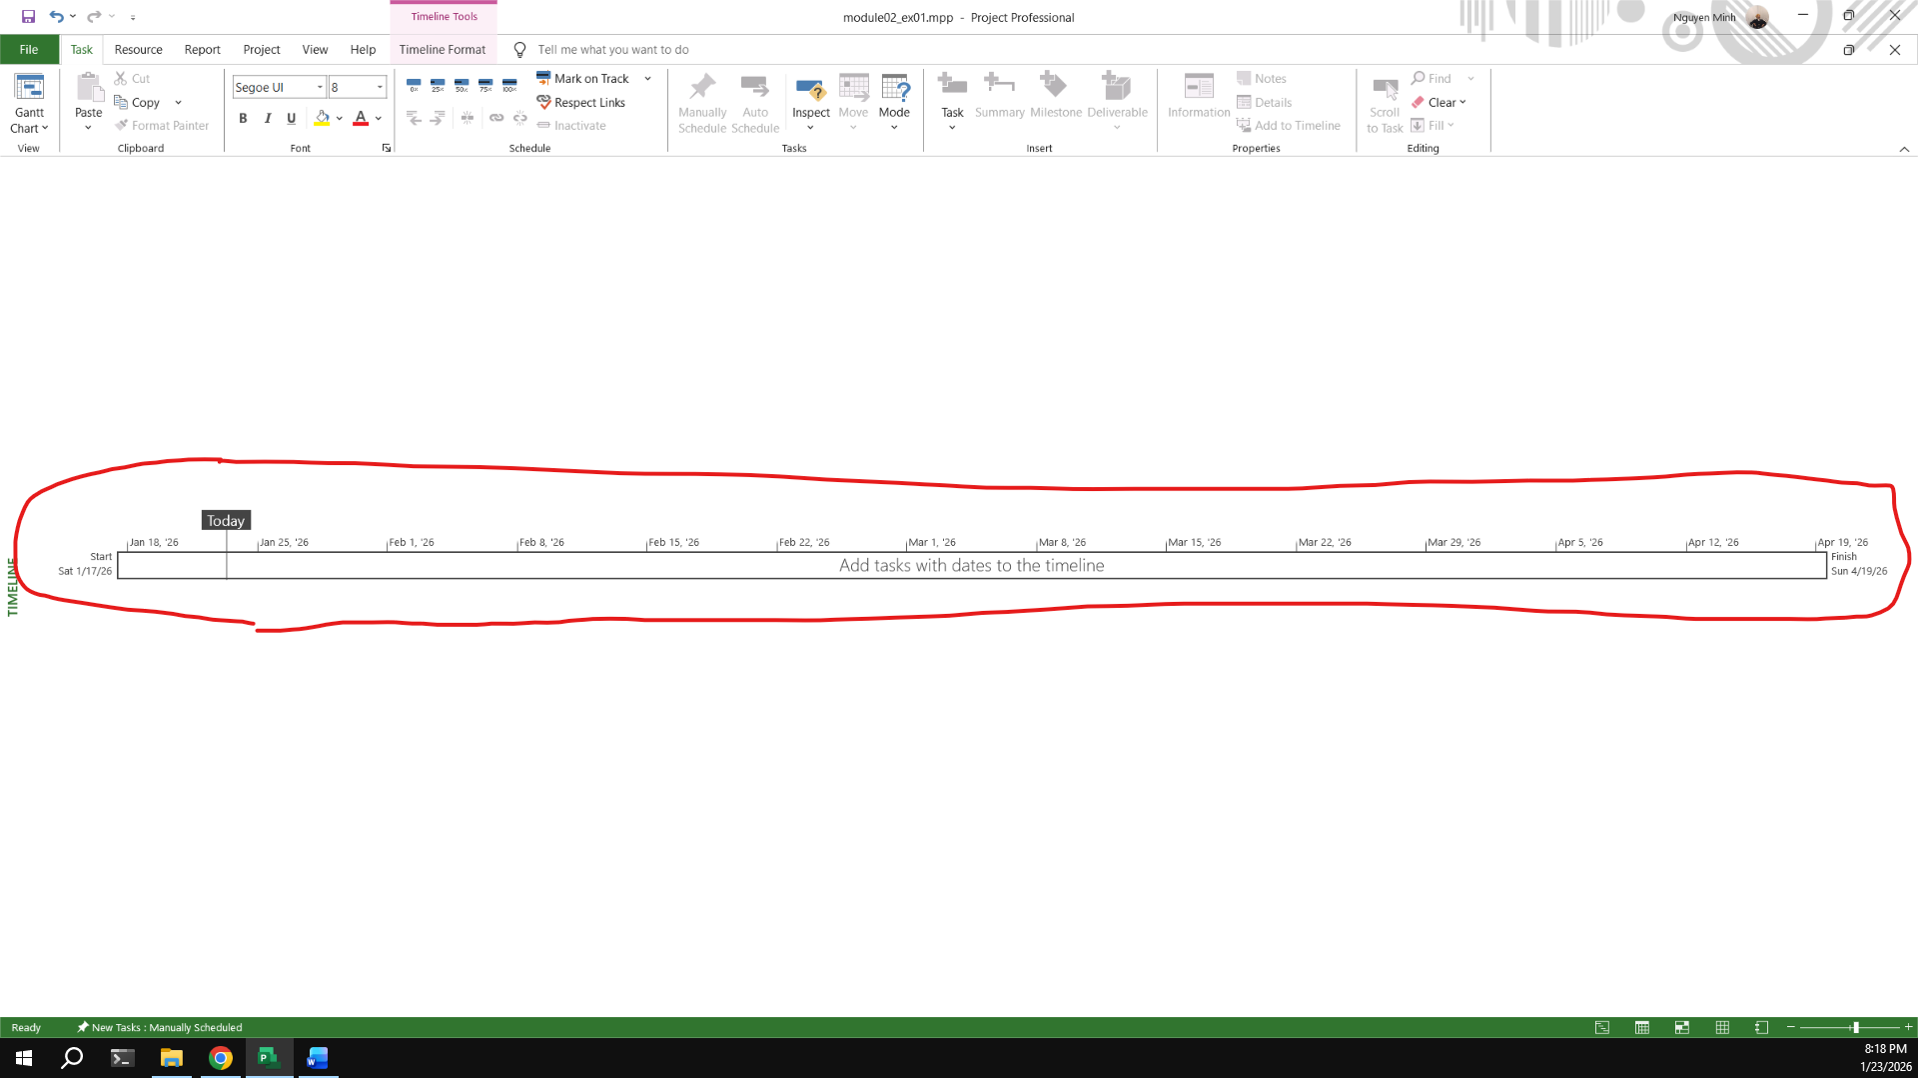

## Exercise 2:

**Changing Working Time**

**Open project file Ex4 (Module 1) Use the Project Information dialog box to:**

Start Date: Nov 20th 2025

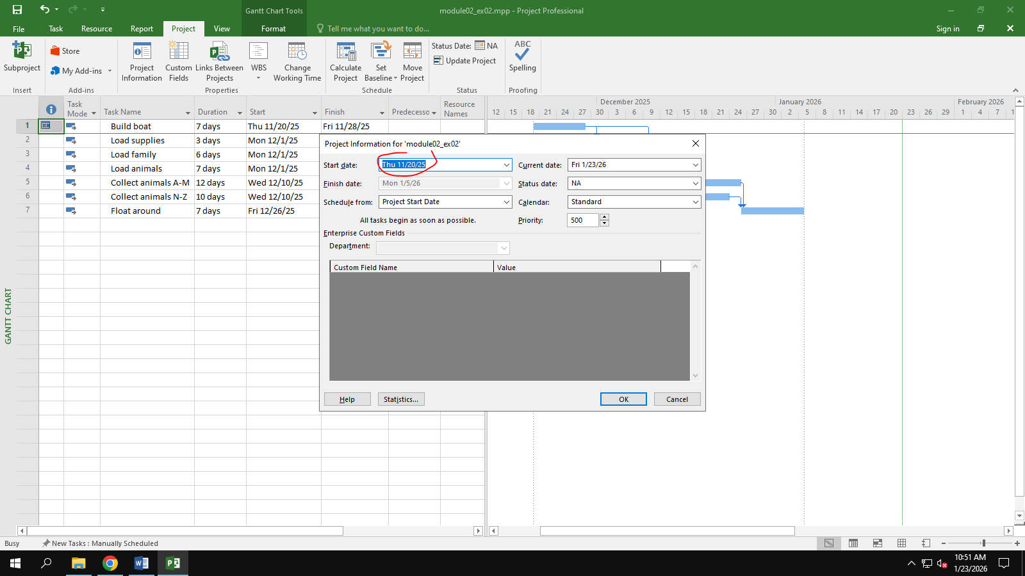

Go to the Change Working Time dialog box and create an Exception called "Tet Holidays" during from Dec 24th 2026 to Jan 5th 2026 into nonworking time.

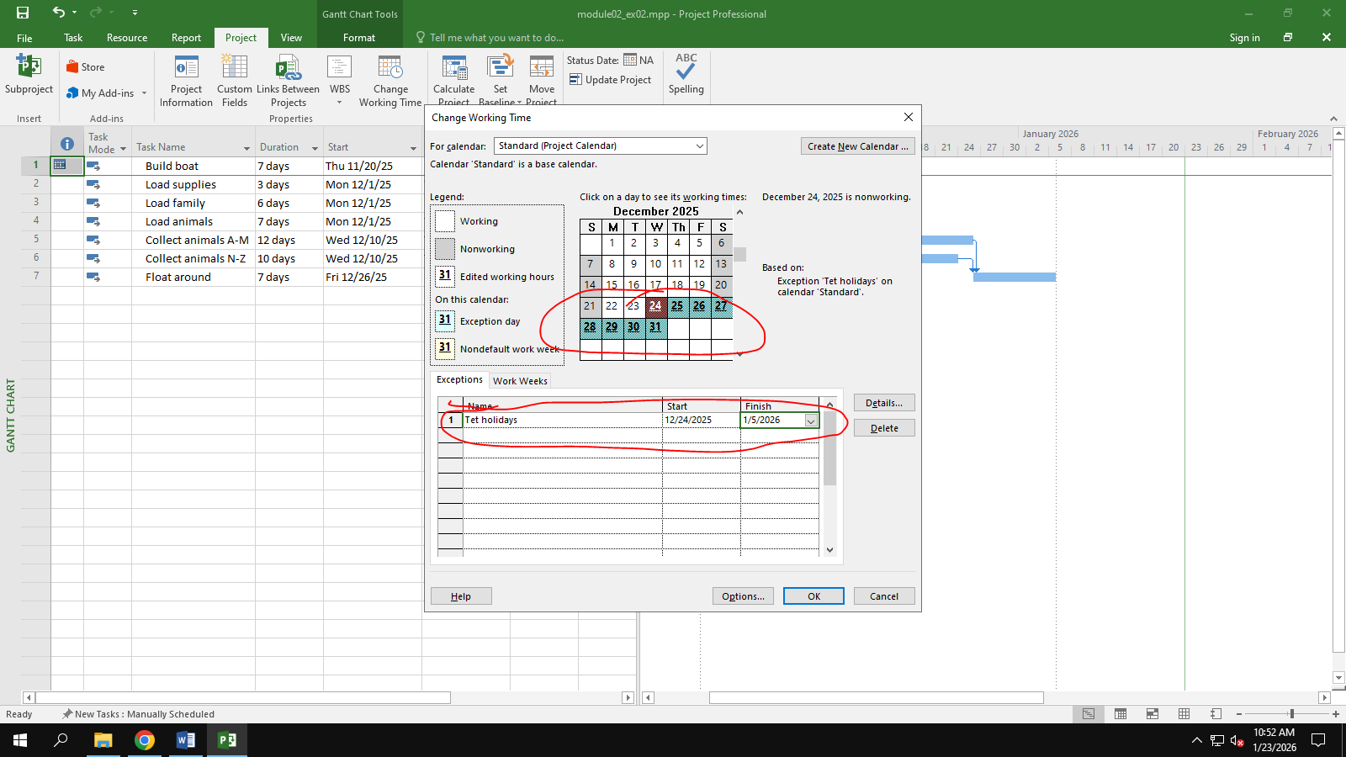

Change Work Weeks time of Standard calendar's default working week. This project's standard working time are:

¬ 08:30 to 17:30 Monday to Thursday (no lunch break)

¬ 08:30 to 16:00 on Fridays (no lunch break)

¬ Add a new Work Week to the Standard calendar named "Xmas Slowdown". Use this to model a 12:30 finish on every weekday from Dec 10th 2025 to Dec 23rd 2025.

¬ Capture the Work weeks time

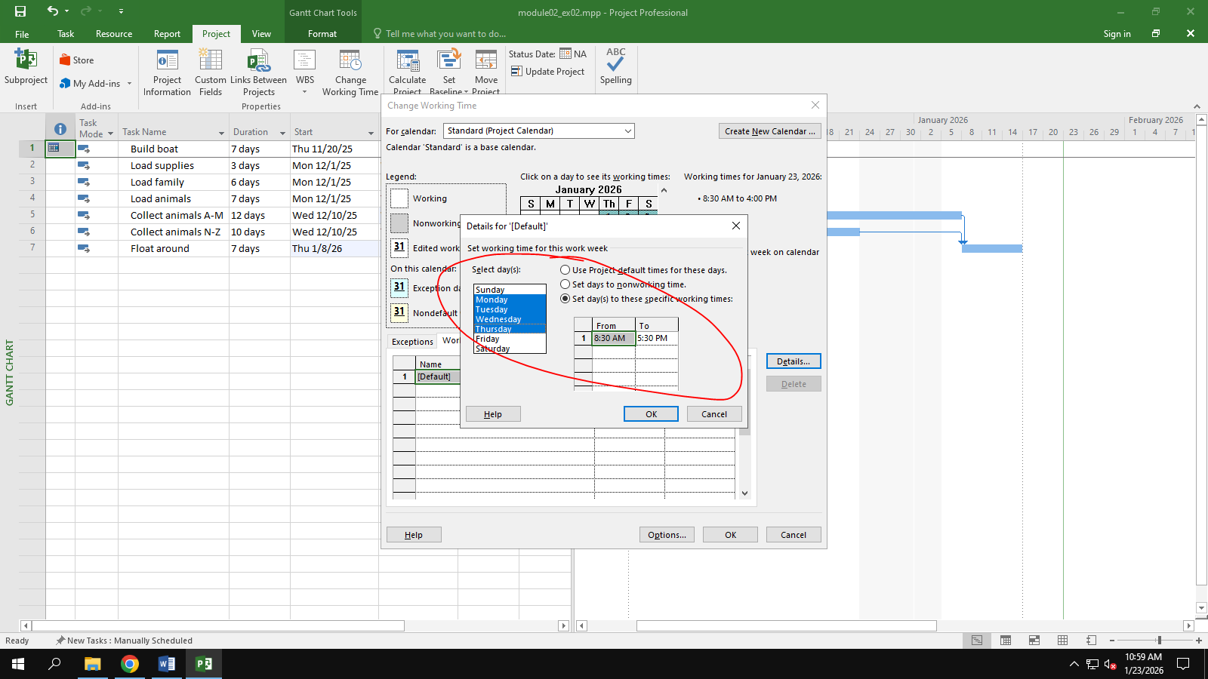

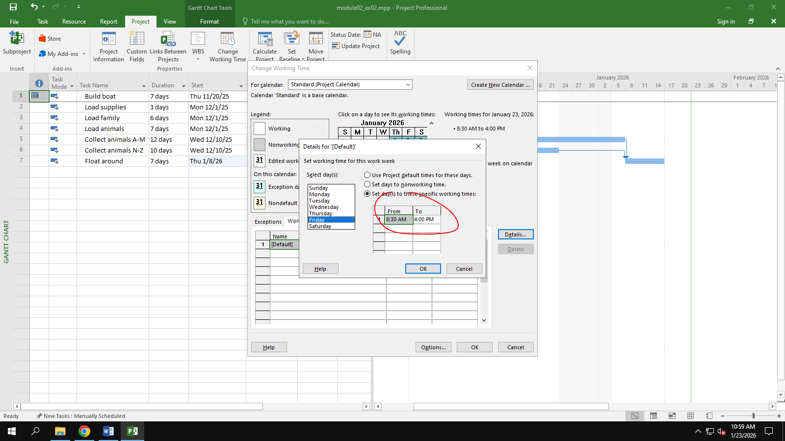

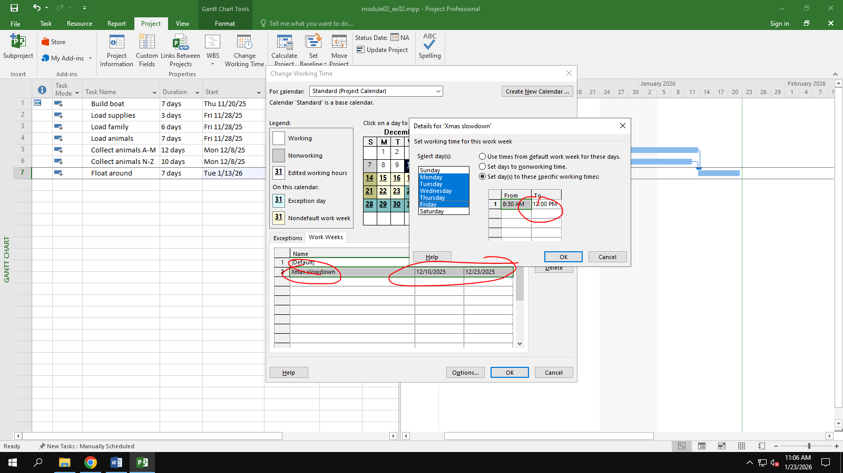

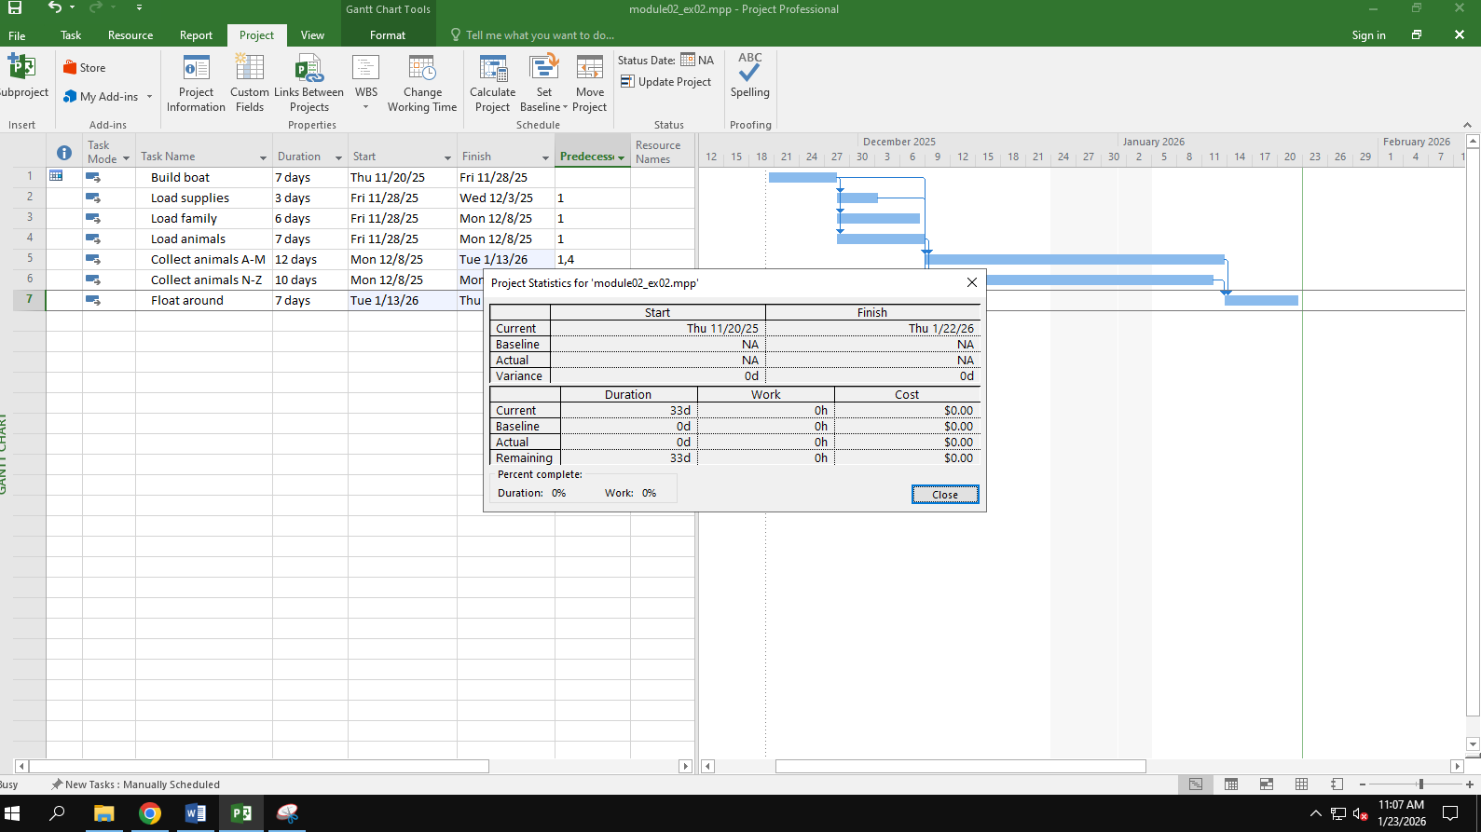

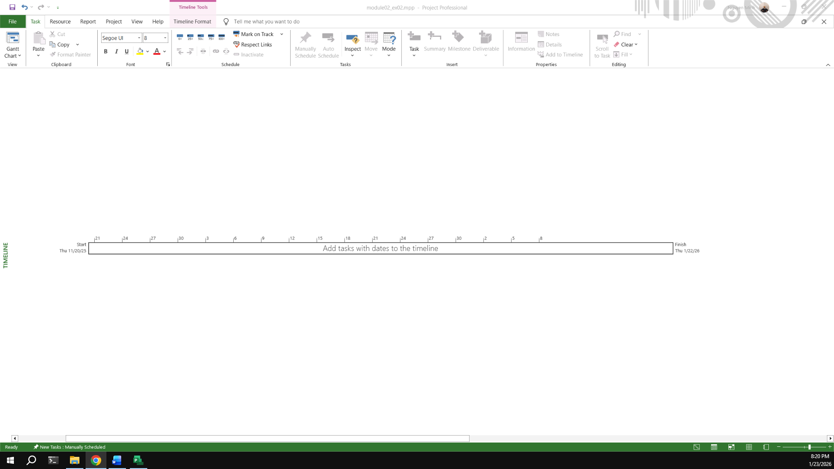

## Exercise 3:

Open project file Ex5 (Module 1), Use the Project Information dialog box to:

Star Date: Apr 5th 2026

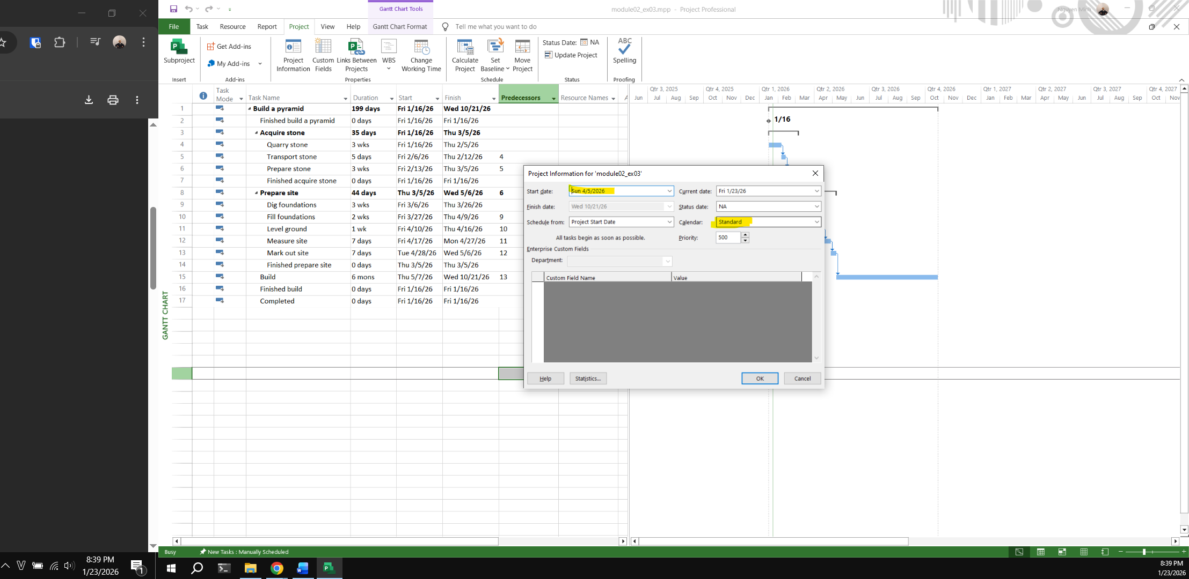

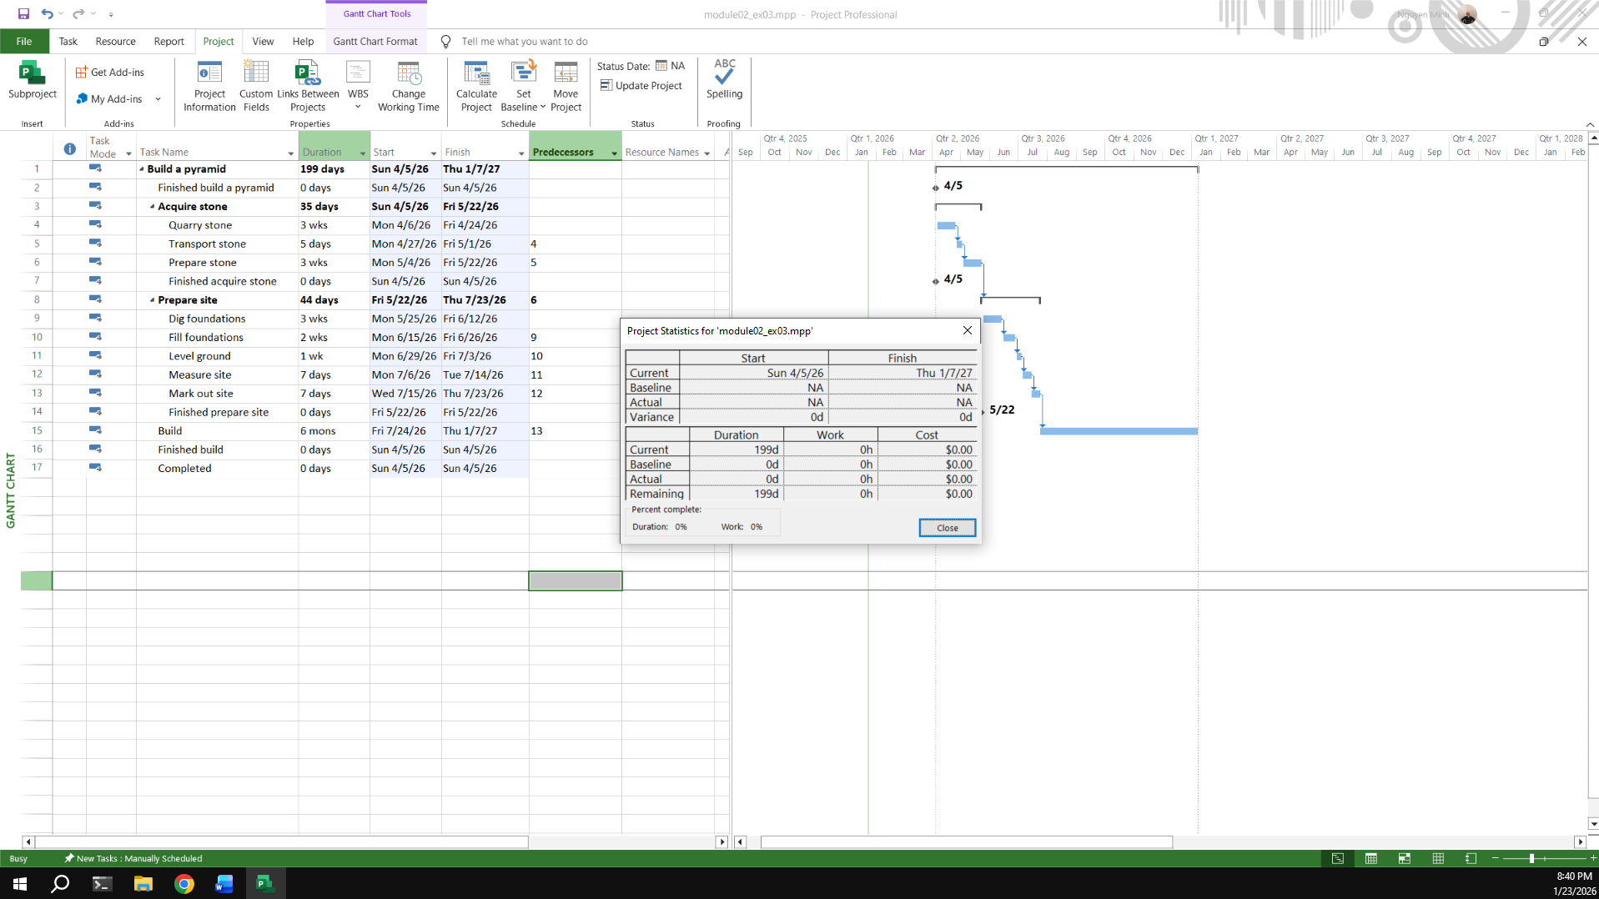

The office will shut down for 2 weeks in the summer. Use the Change Working Time dialog box to create an Exception called "Summer Shutdown" and make the first 14 workdays of August nonworking time

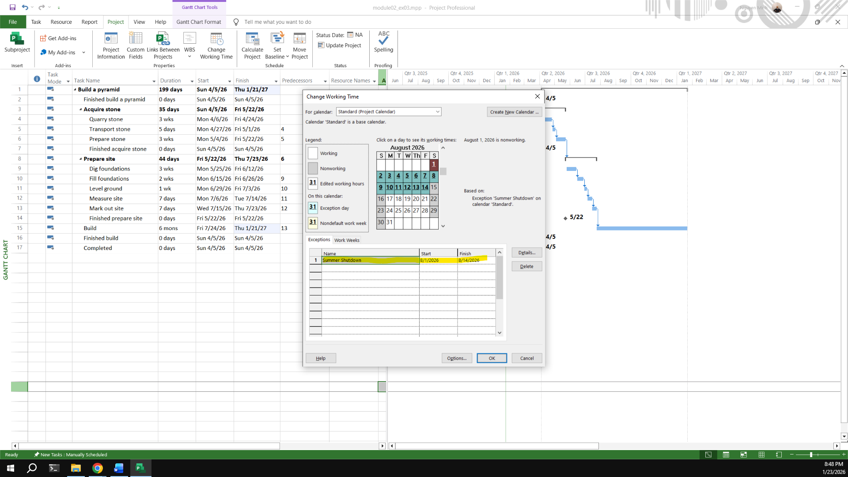

Create an Exception called “Independence Days” is 2 Sep nonworking time.

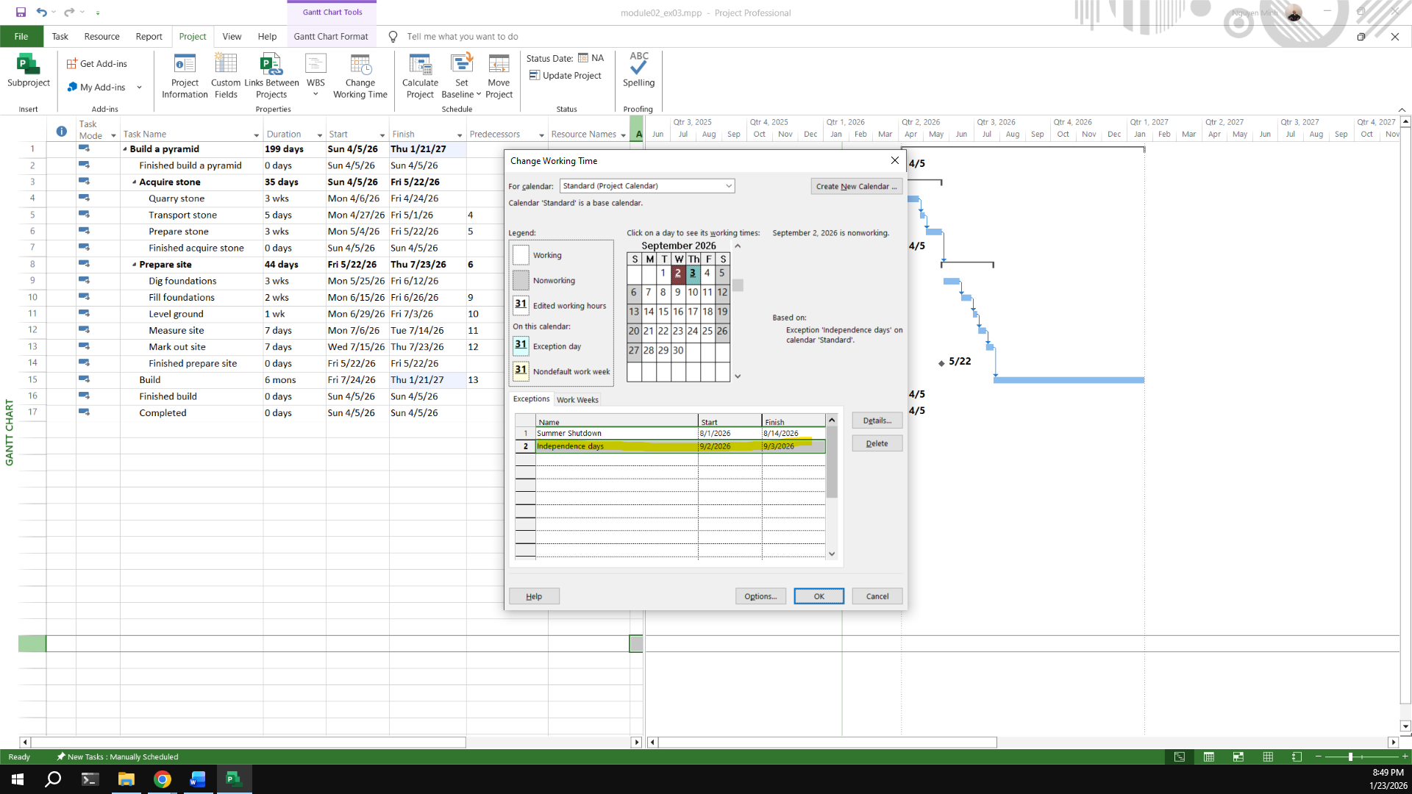

Create an Exception called “International Labor days” is Apr 30th and May 1st nonworking time

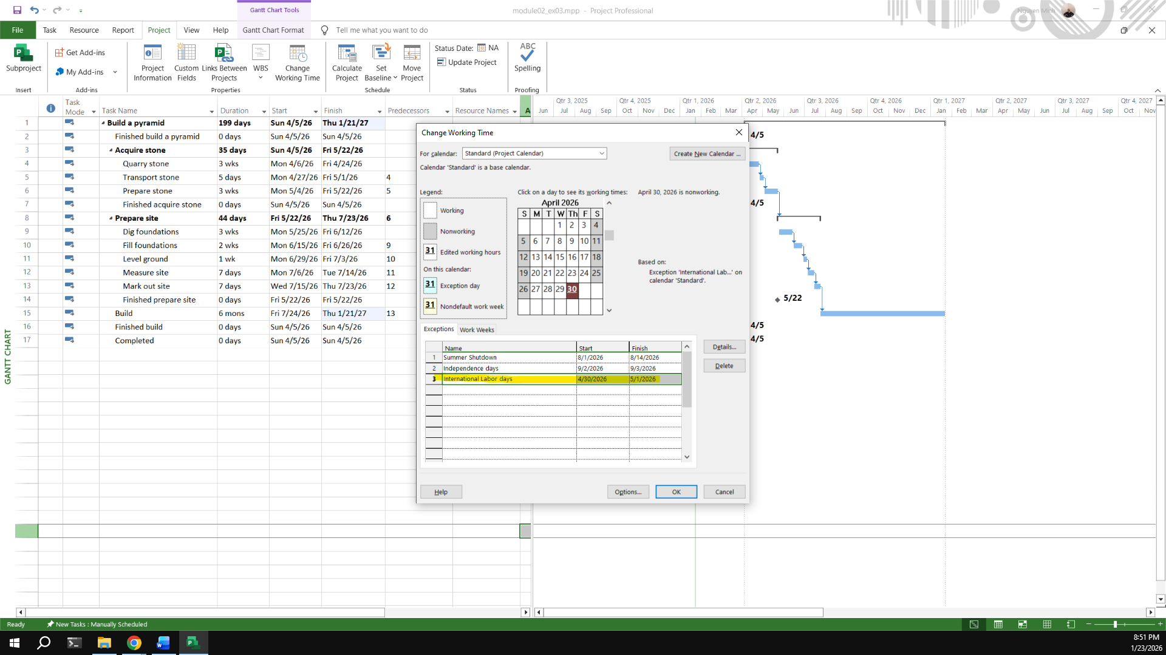

Display the Project Information

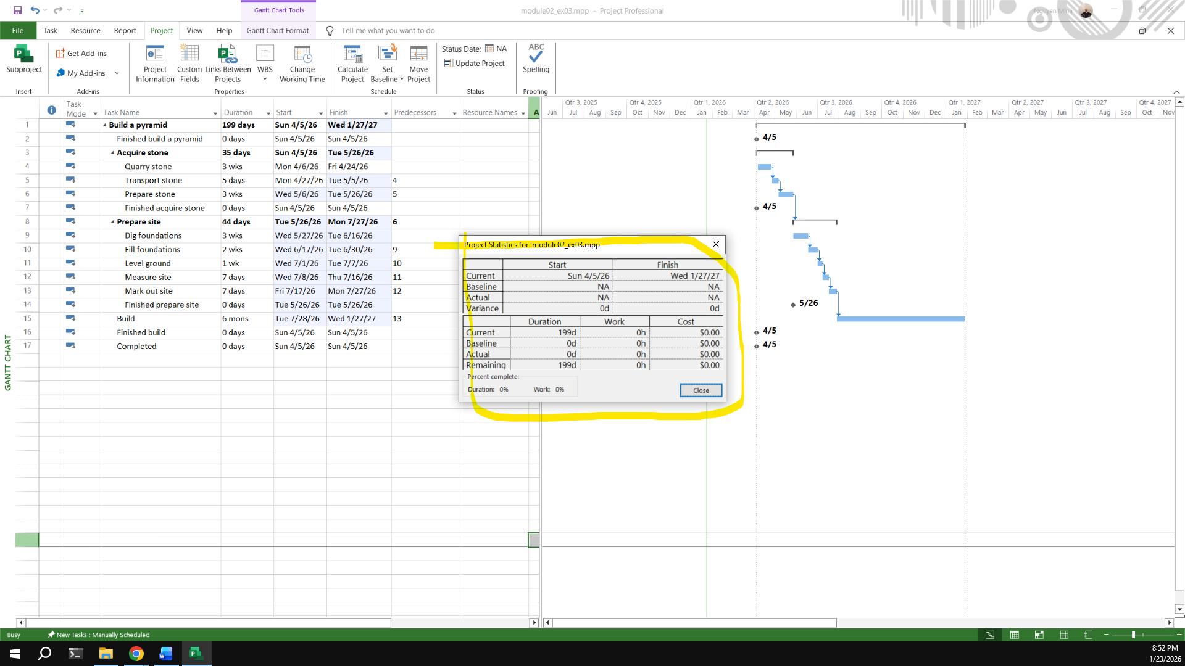

## Exercise 4:

Open project file Ex6 (Module 1), Use the Project Information dialog box to:

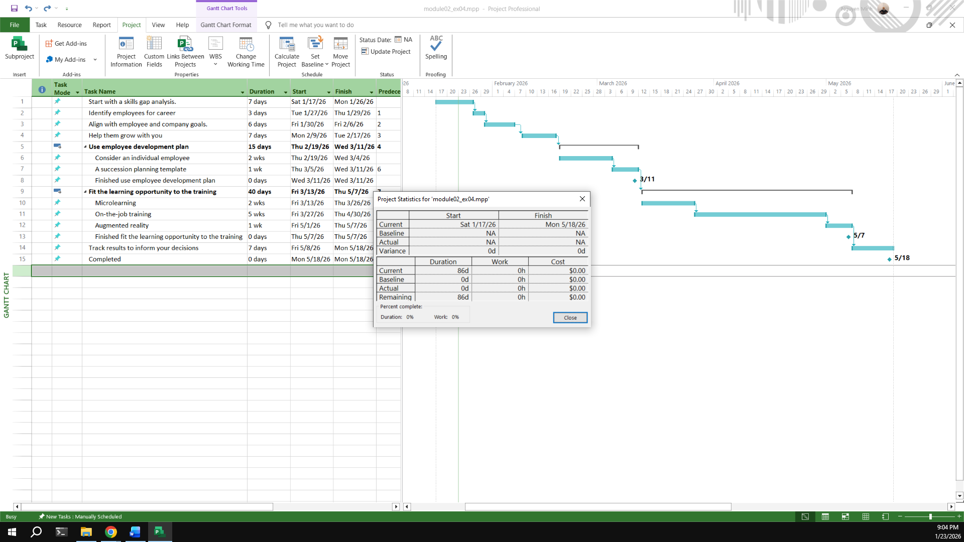

Modify the Standard calendar and change the [Default] work week to use the hours shown below:

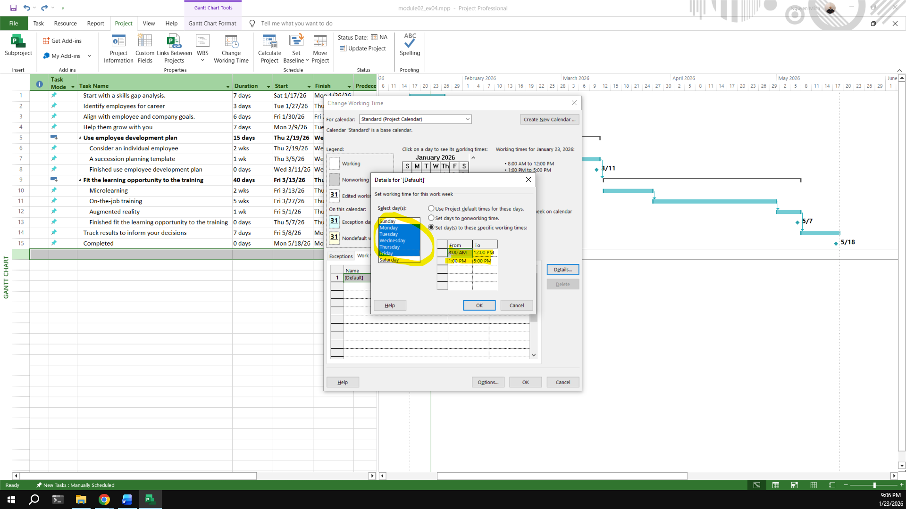

Add an exception in the Standard calendar called Recovery with in 7 lates workdays of March is non-working days.

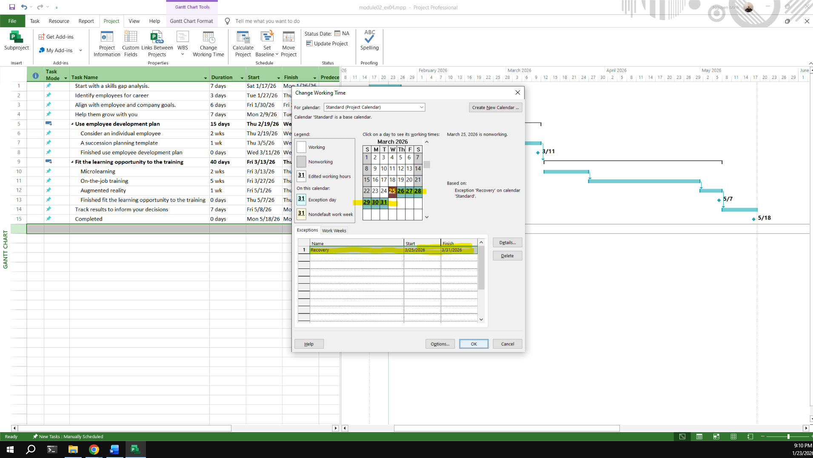

Display the Project Information.

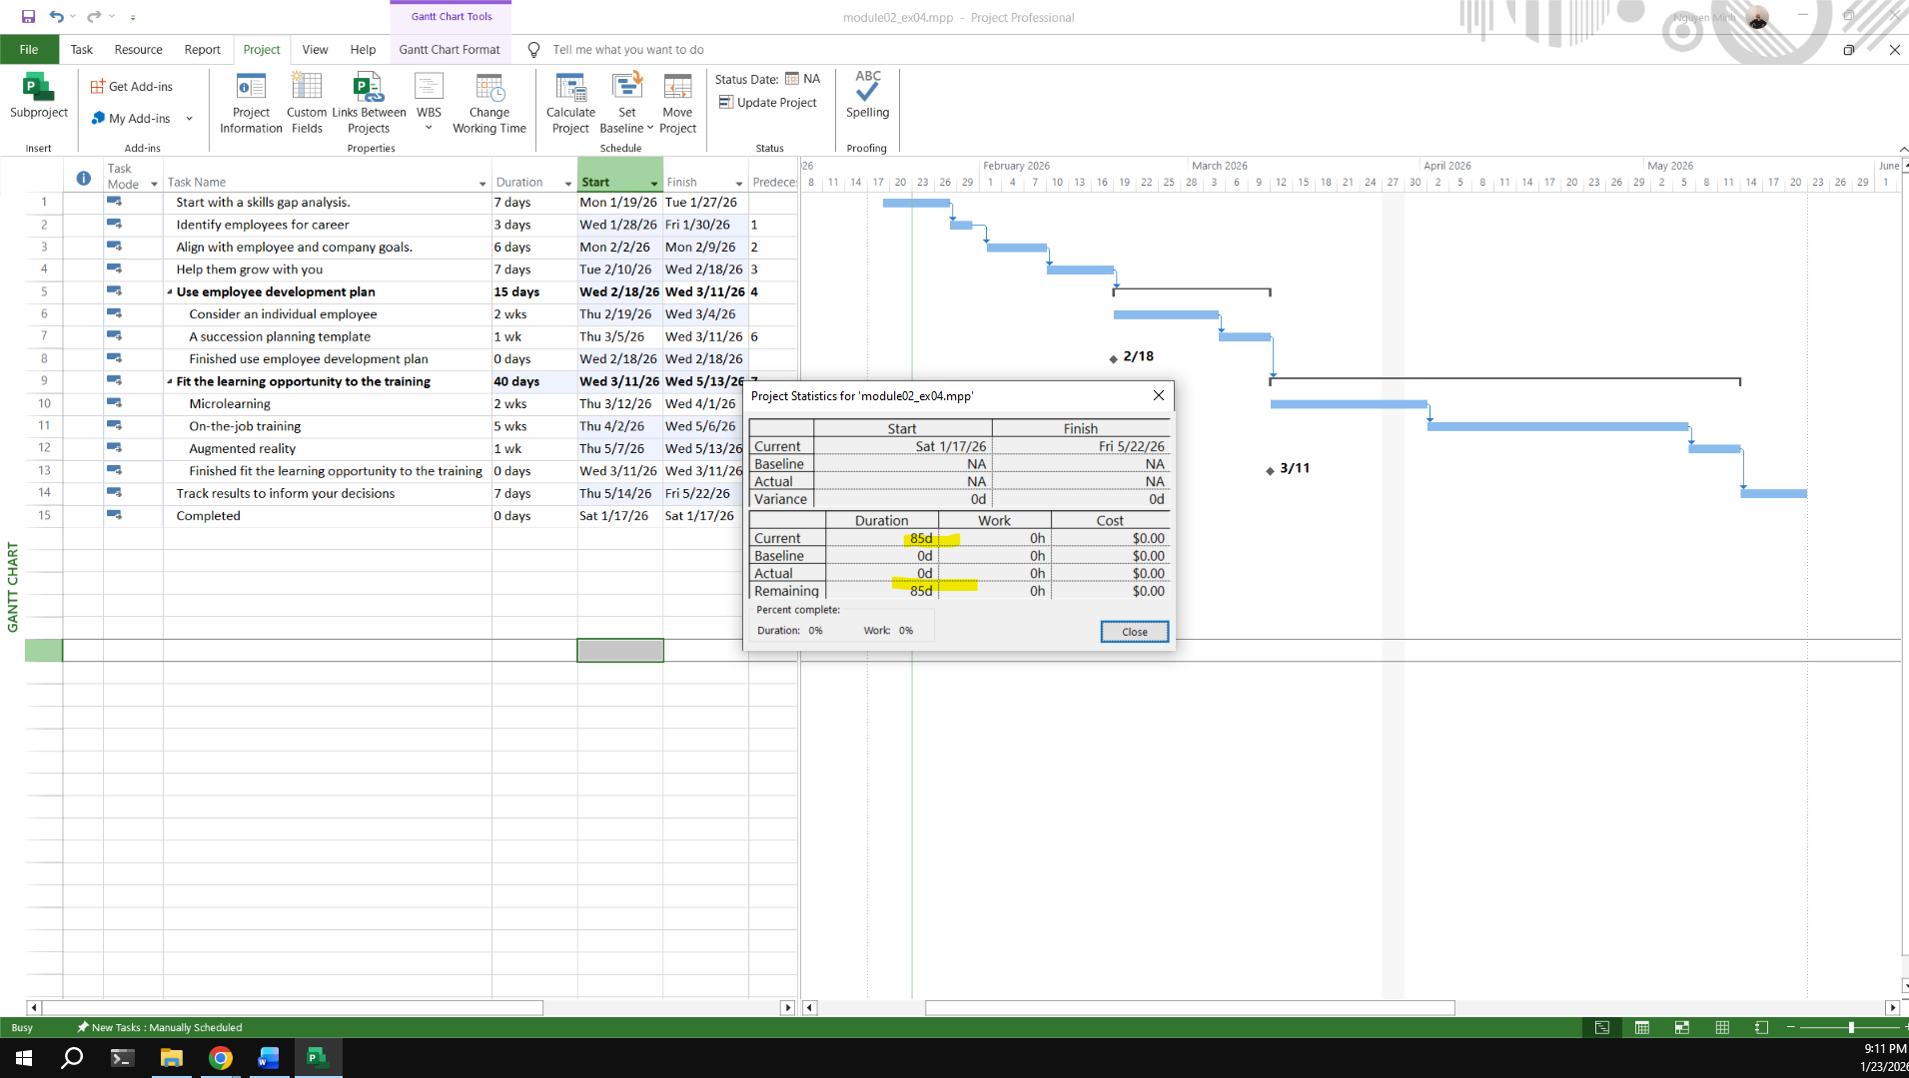

## Exercise 5:

Open project file Ex7 (Module 1), Use the Project Information dialog box to:

Create the new Time Work for your project.

[NameTimeProject] {Name: Your Name - Ex: MinhTimeProject}

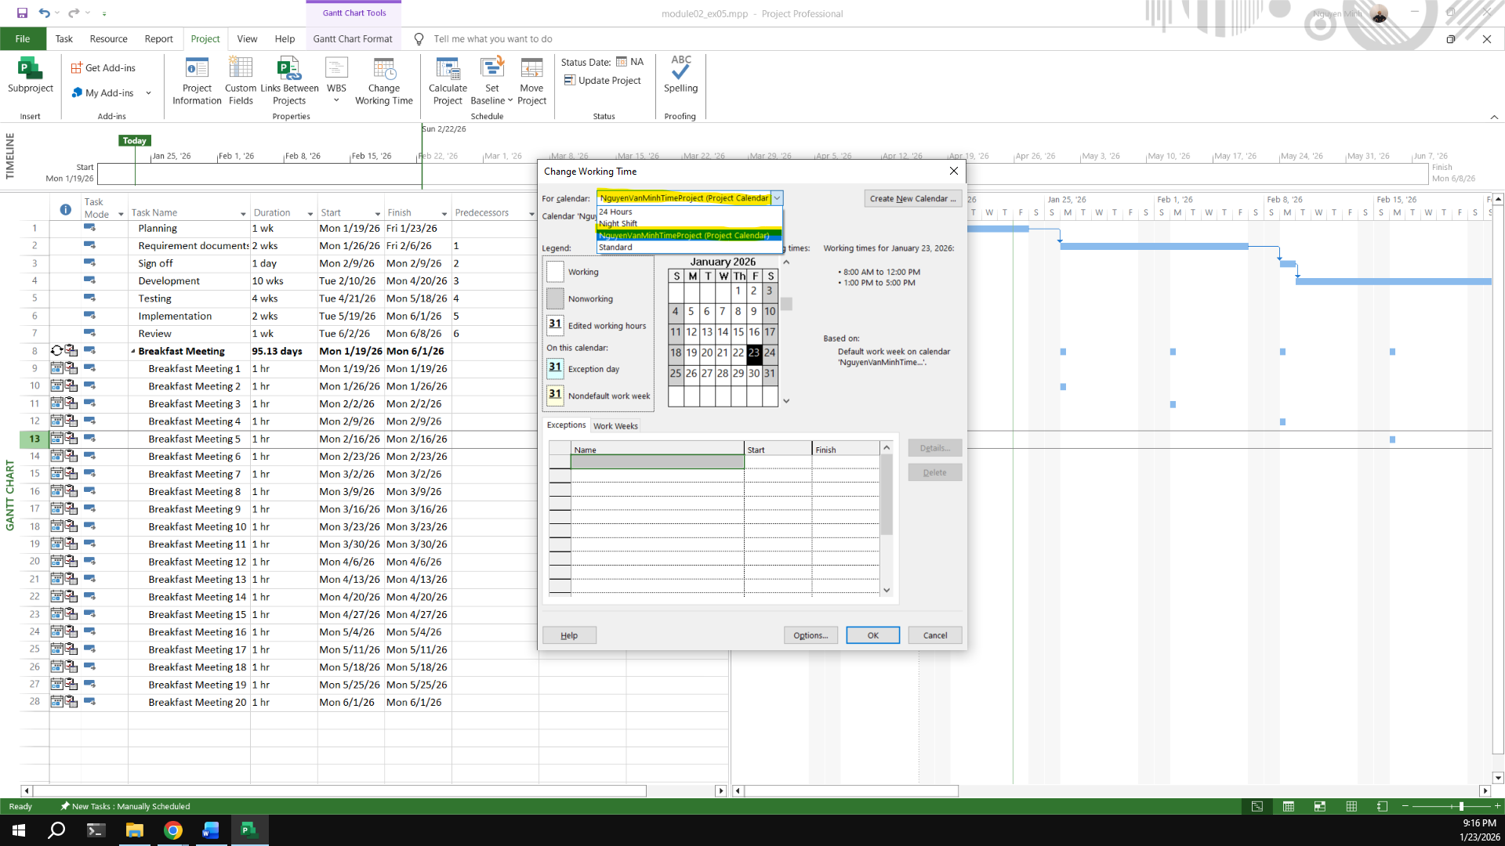

Change Work Weeks time of Standard calendar's default working week. This project's standard working time are:

08:00 to 12:00 on Mon, Wed, Fri

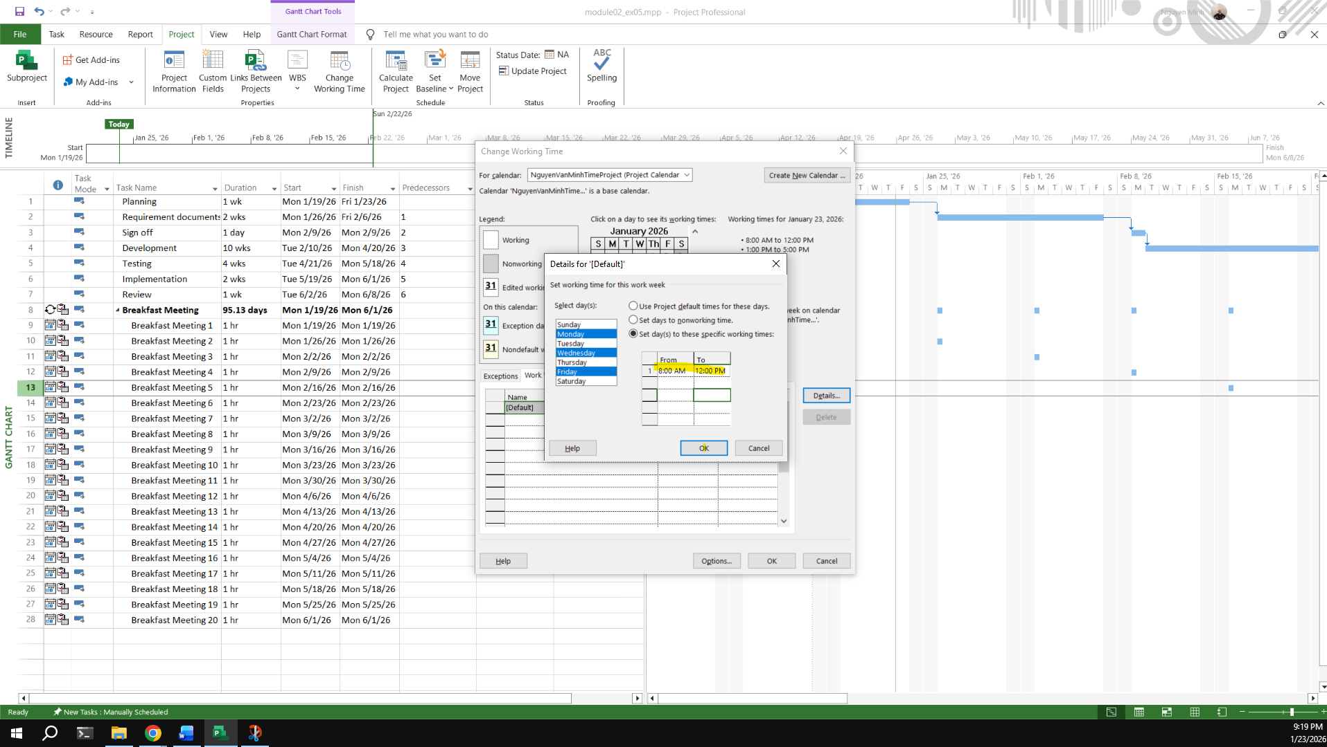

13:00 to 16:00 on Tue, Thu, Sat

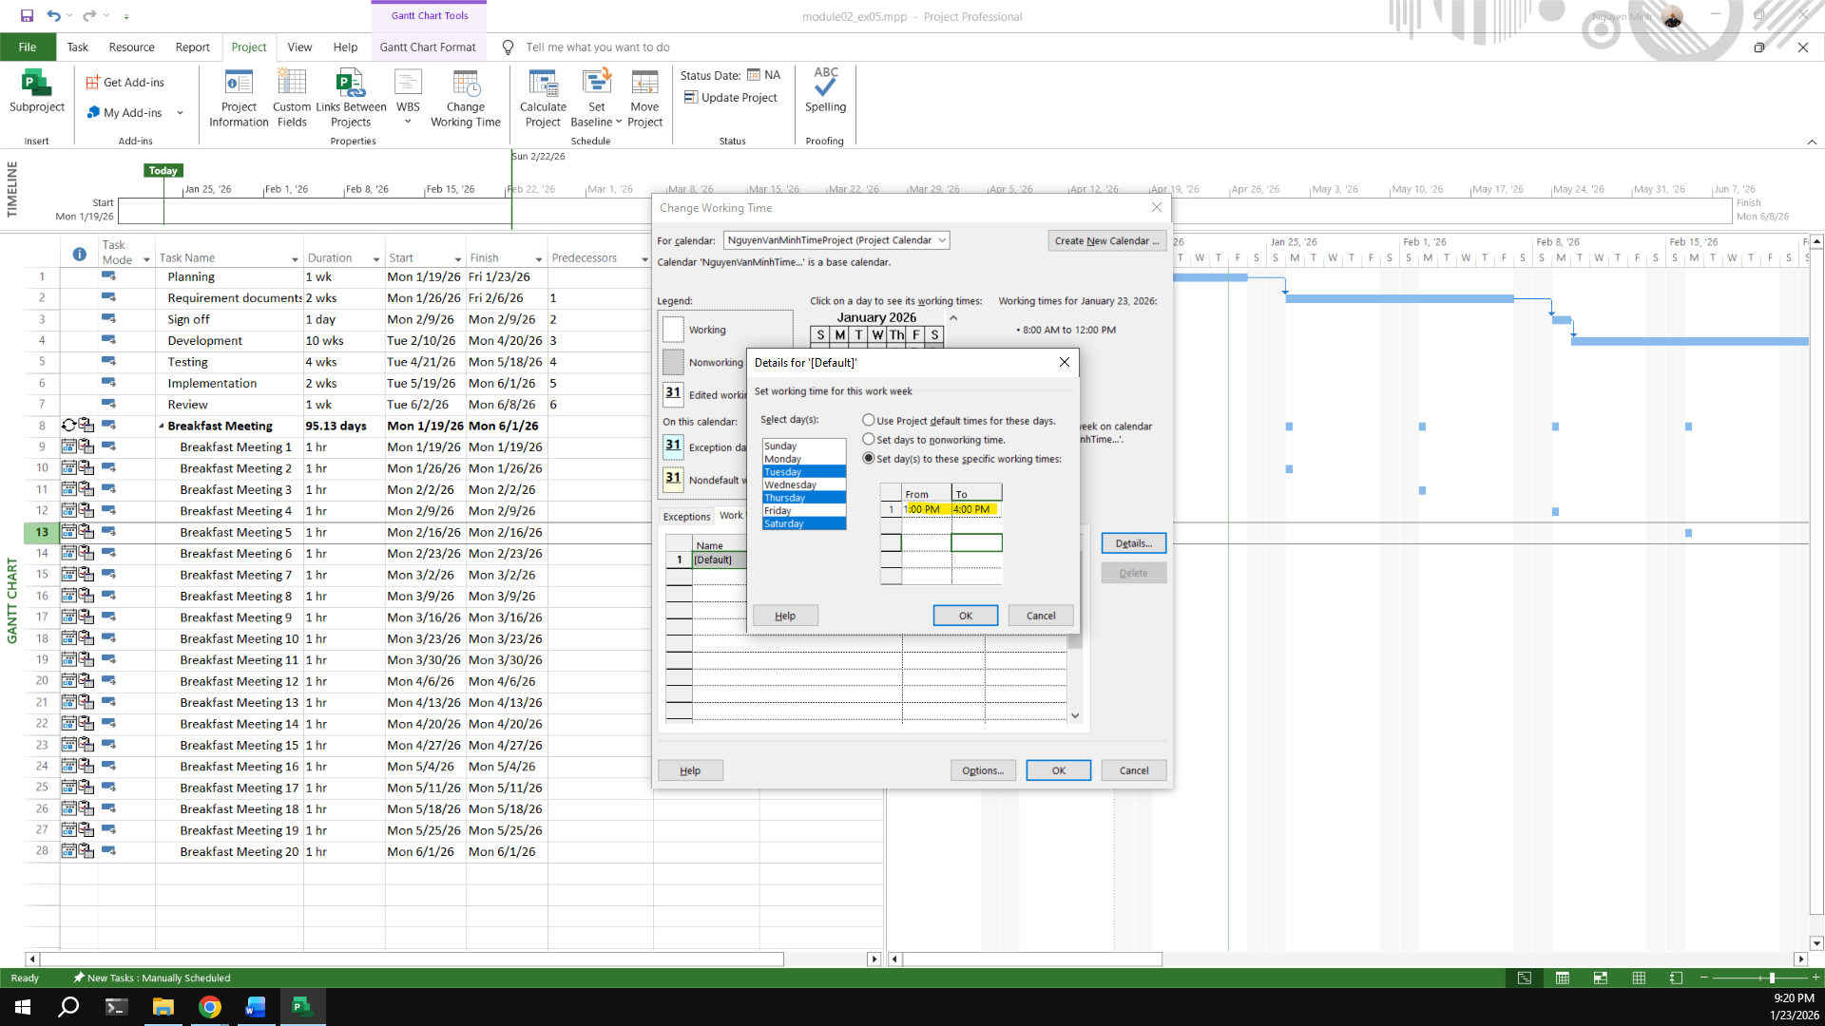

Create an Exception called “International Labor days” is Apr 30th and May 1st nonworking time

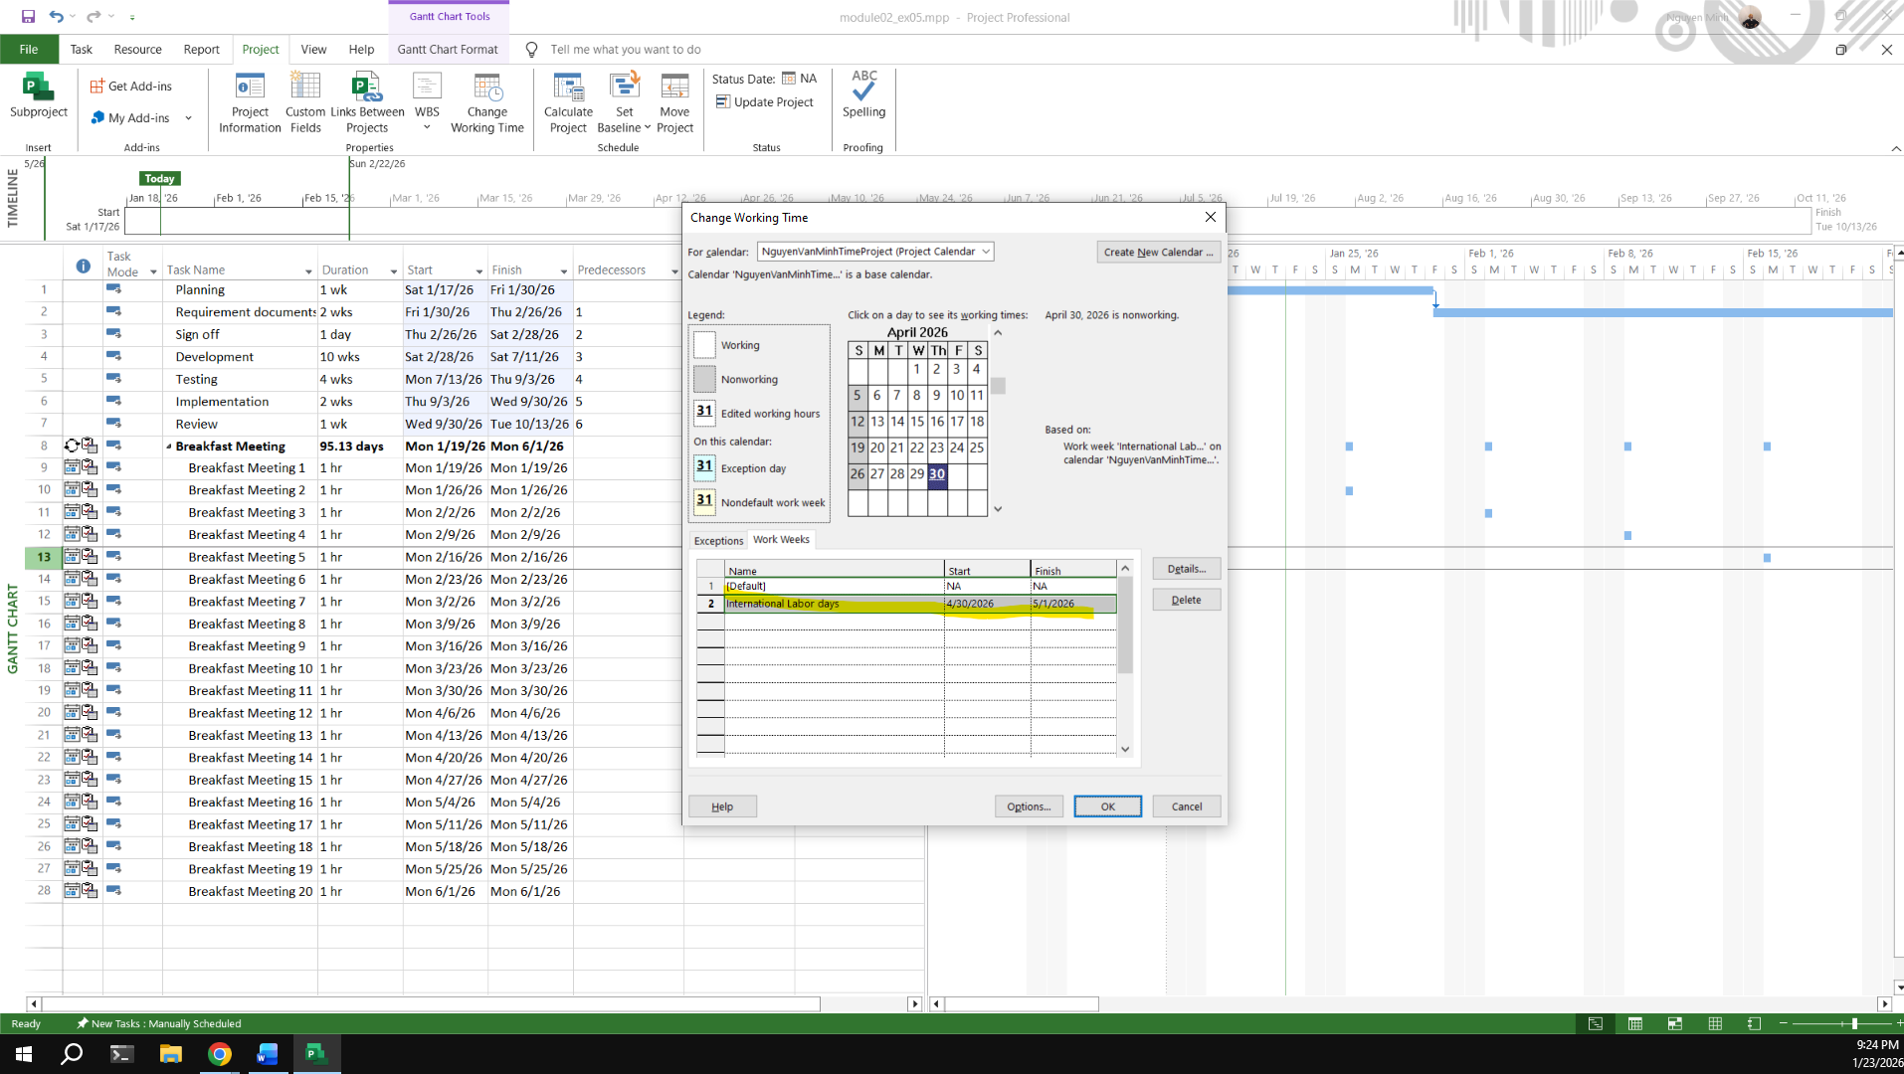

Capture the Work weeks time

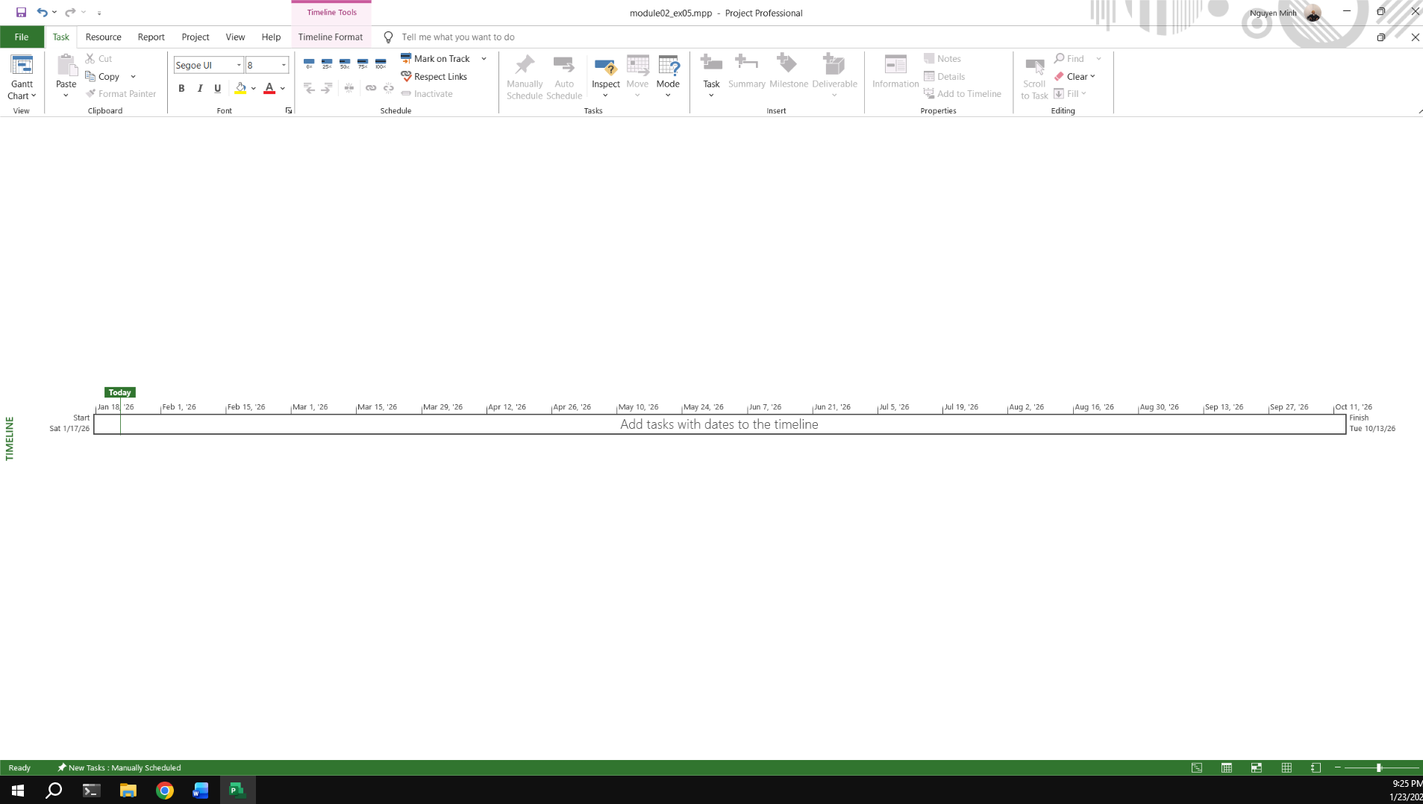

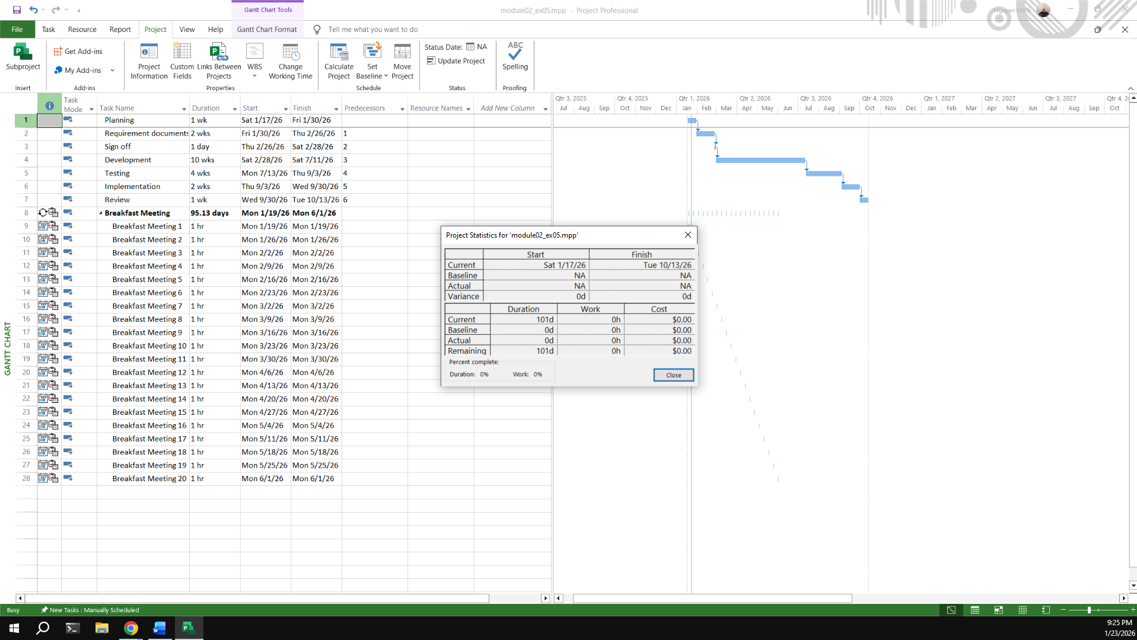

## Exercise 6:

**My project**

**Create your plan from Monday to Sunday. It will list all of your activities, your time you spend and resources joining in each task.**

**Create a new calendar called Student based on the Standard calendar.**

**Change the [Default] work week so that the hours match to your calendar everyday**

**Using Note function in MP 2010 to take note for important tasks in your plan.**

***Kế hoạch công việc tháng (Programmer Monthly Plan)***

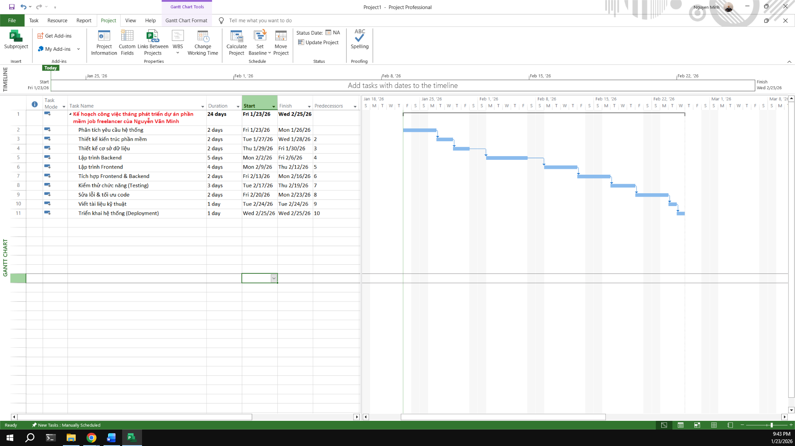

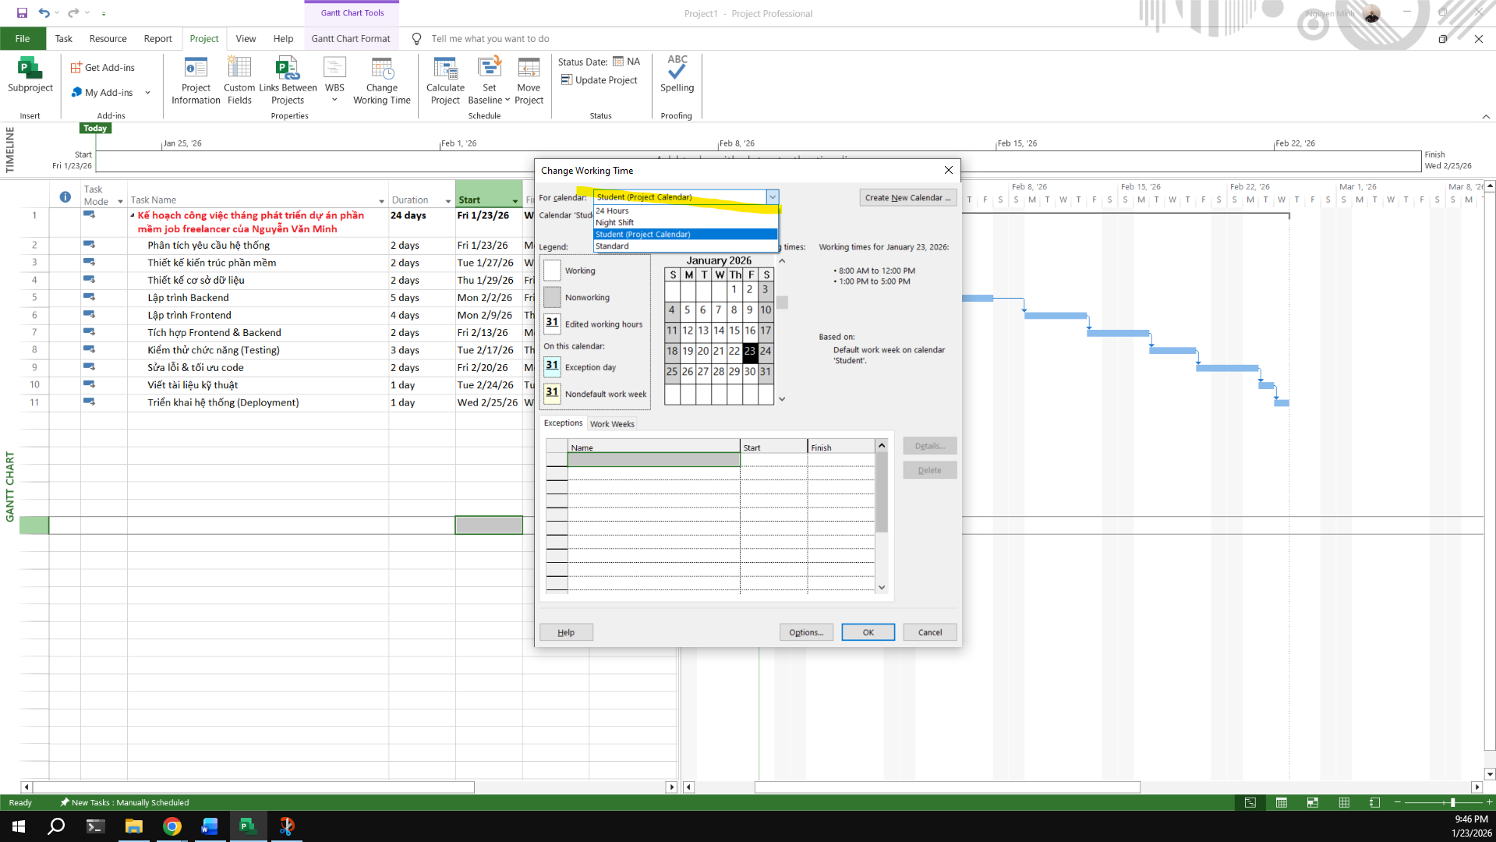

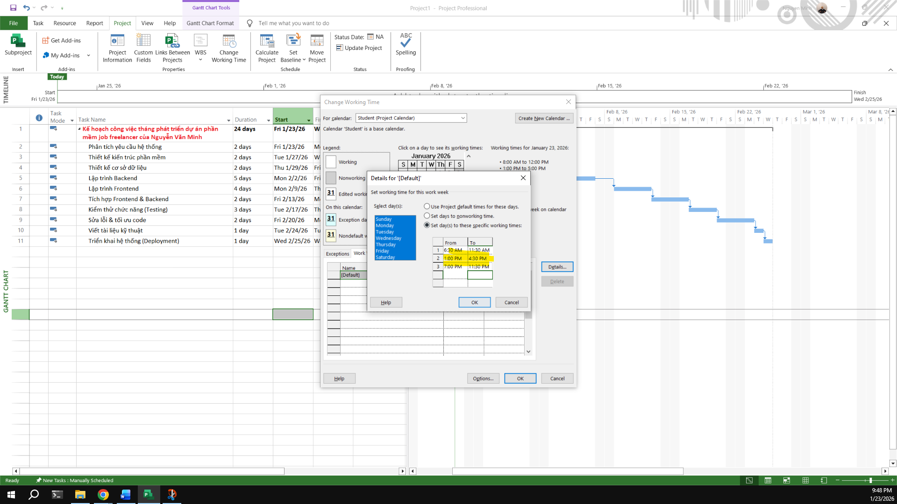

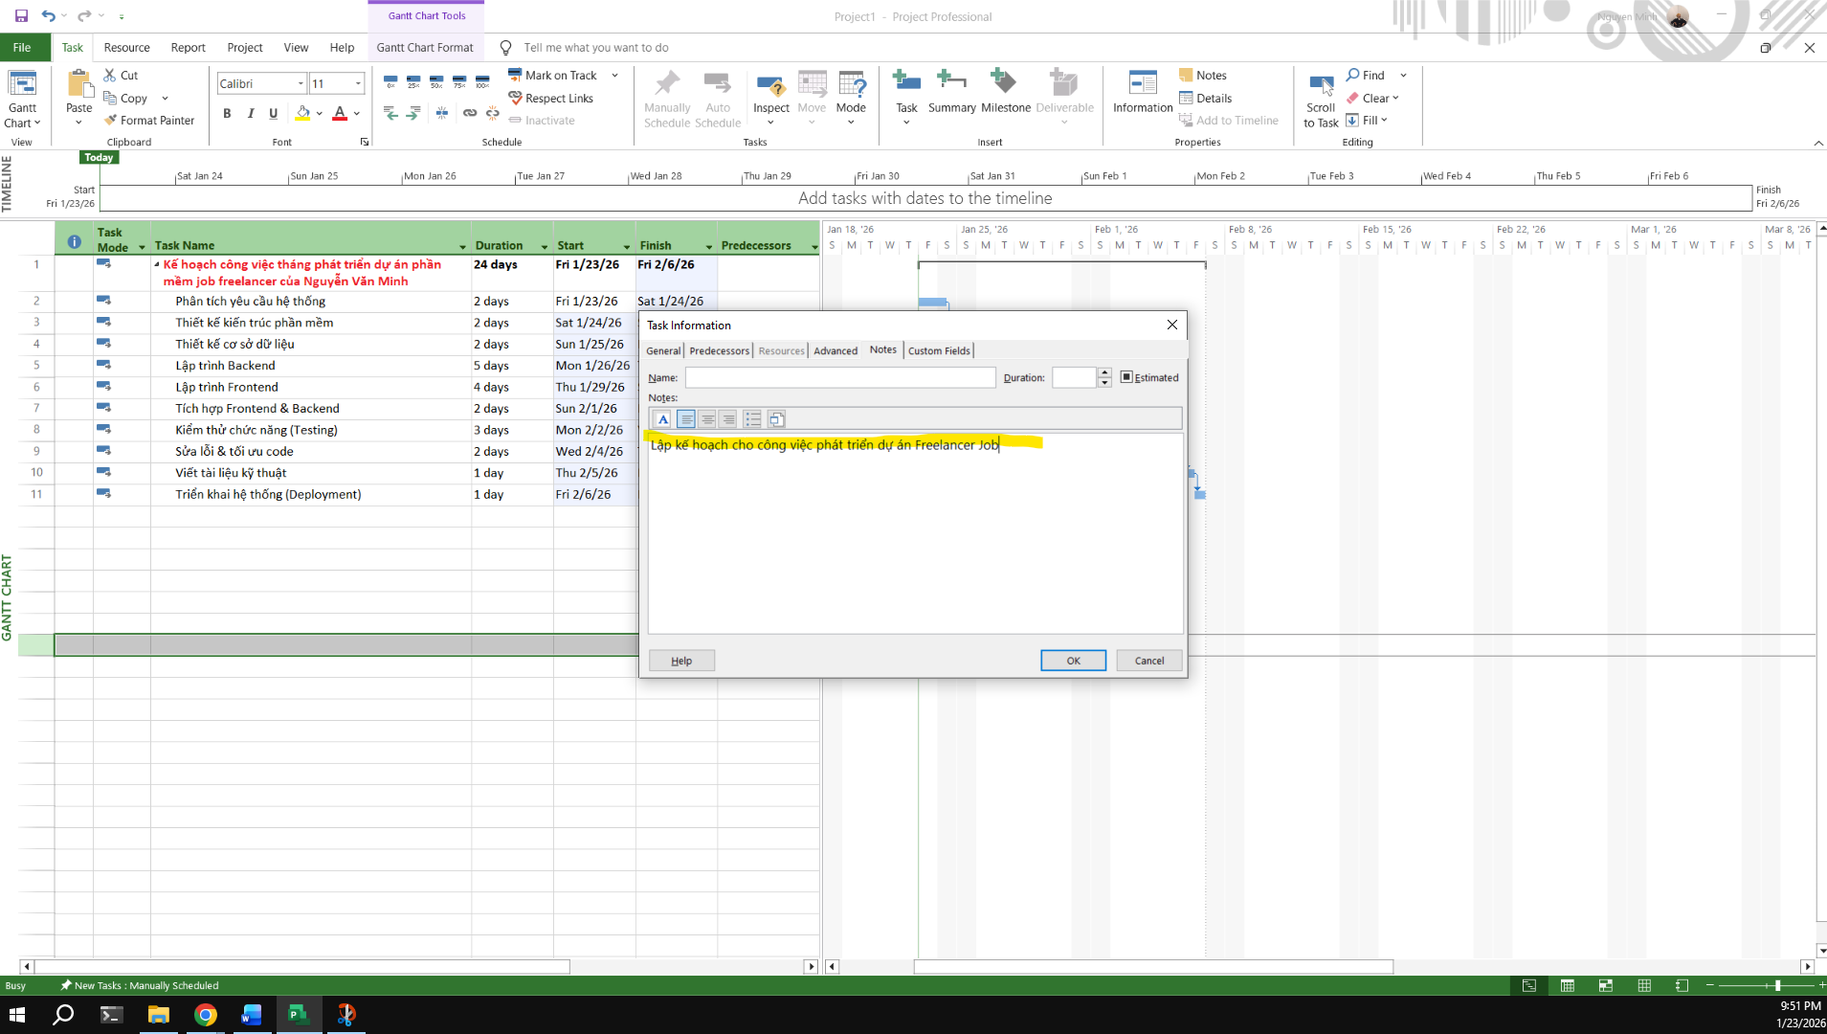

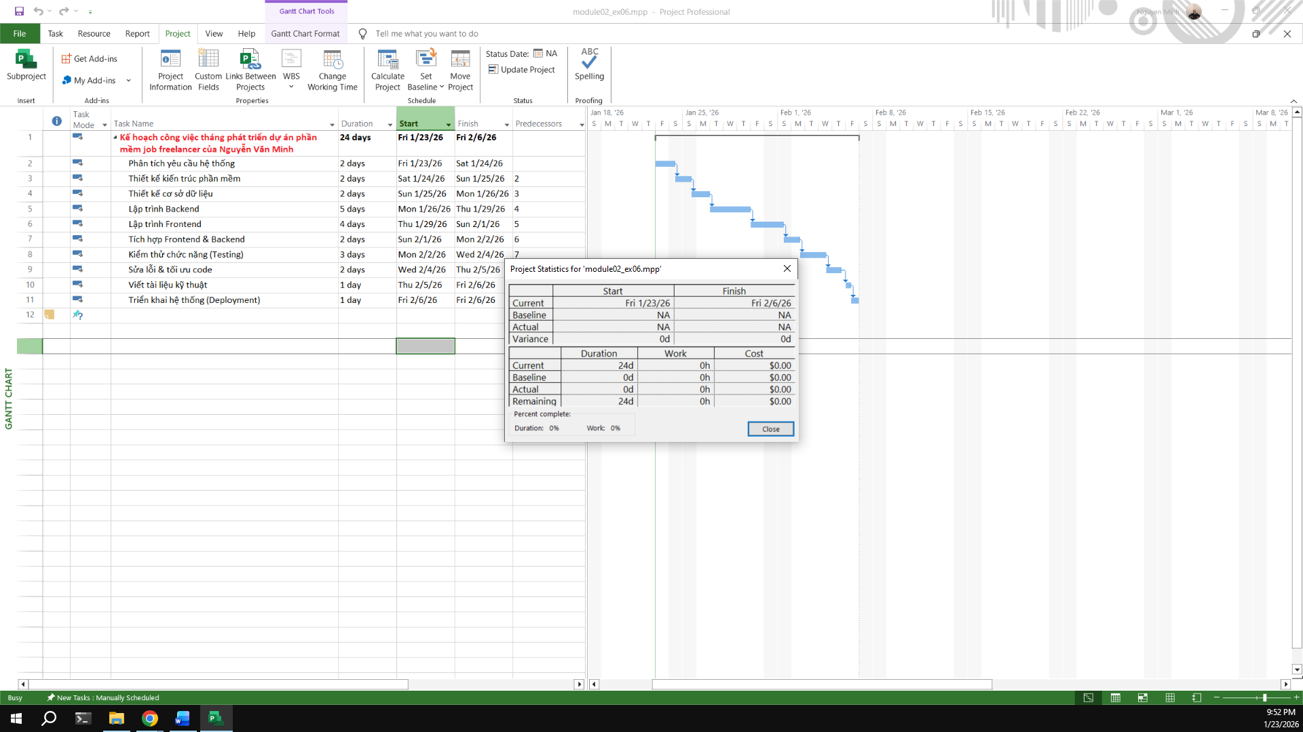

# Module 3:

## Exercise 1:

## 

Display the Project Information.

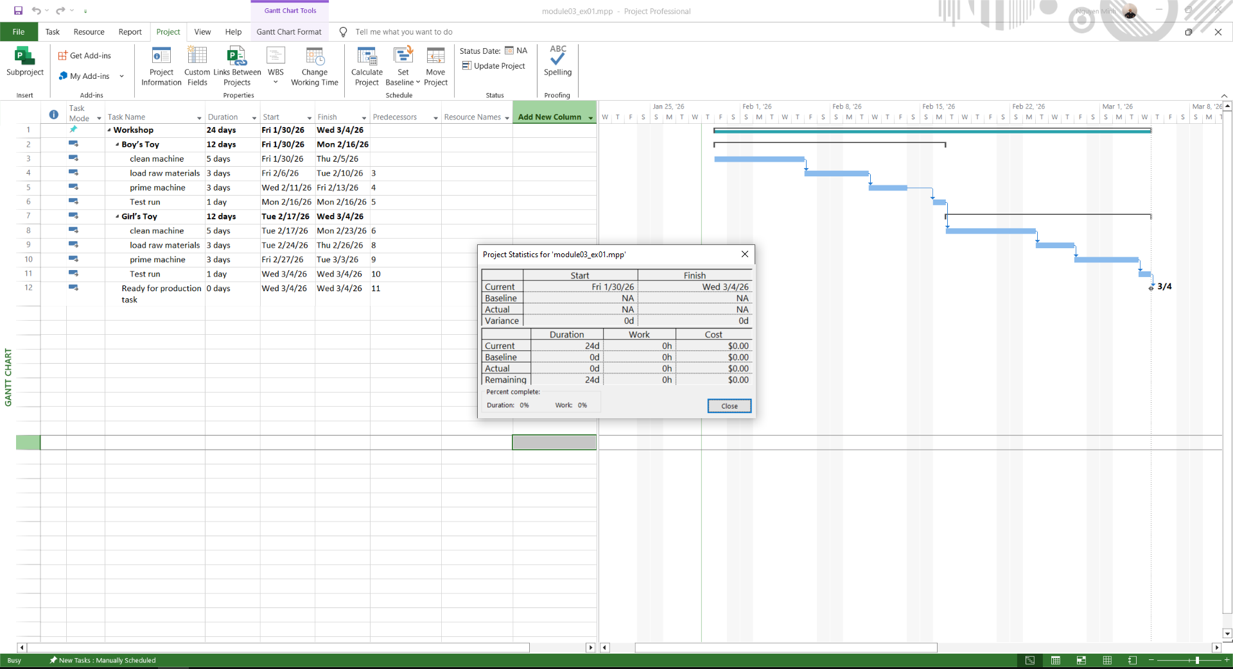

View Project Timeline

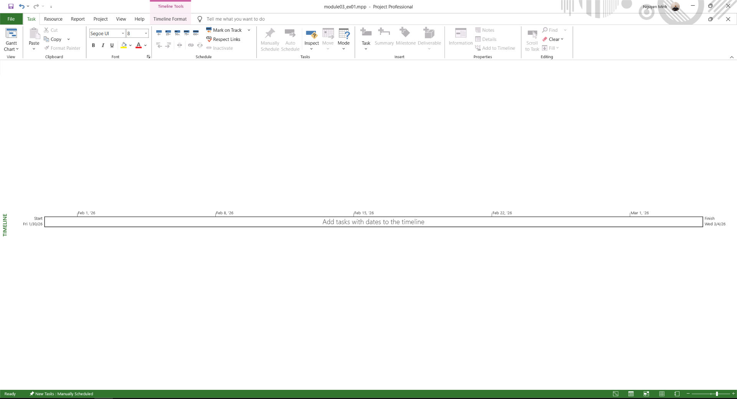

Gantt Chart

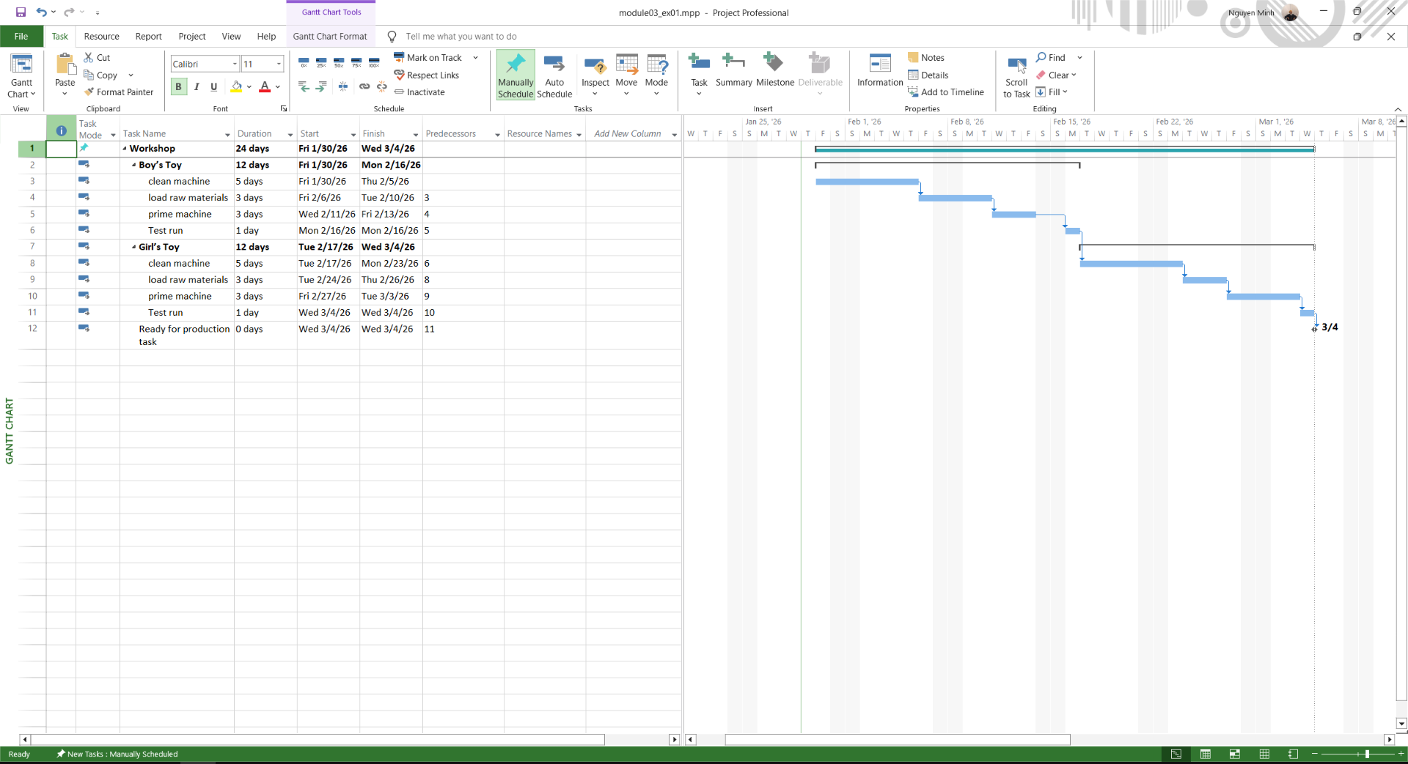

view CP

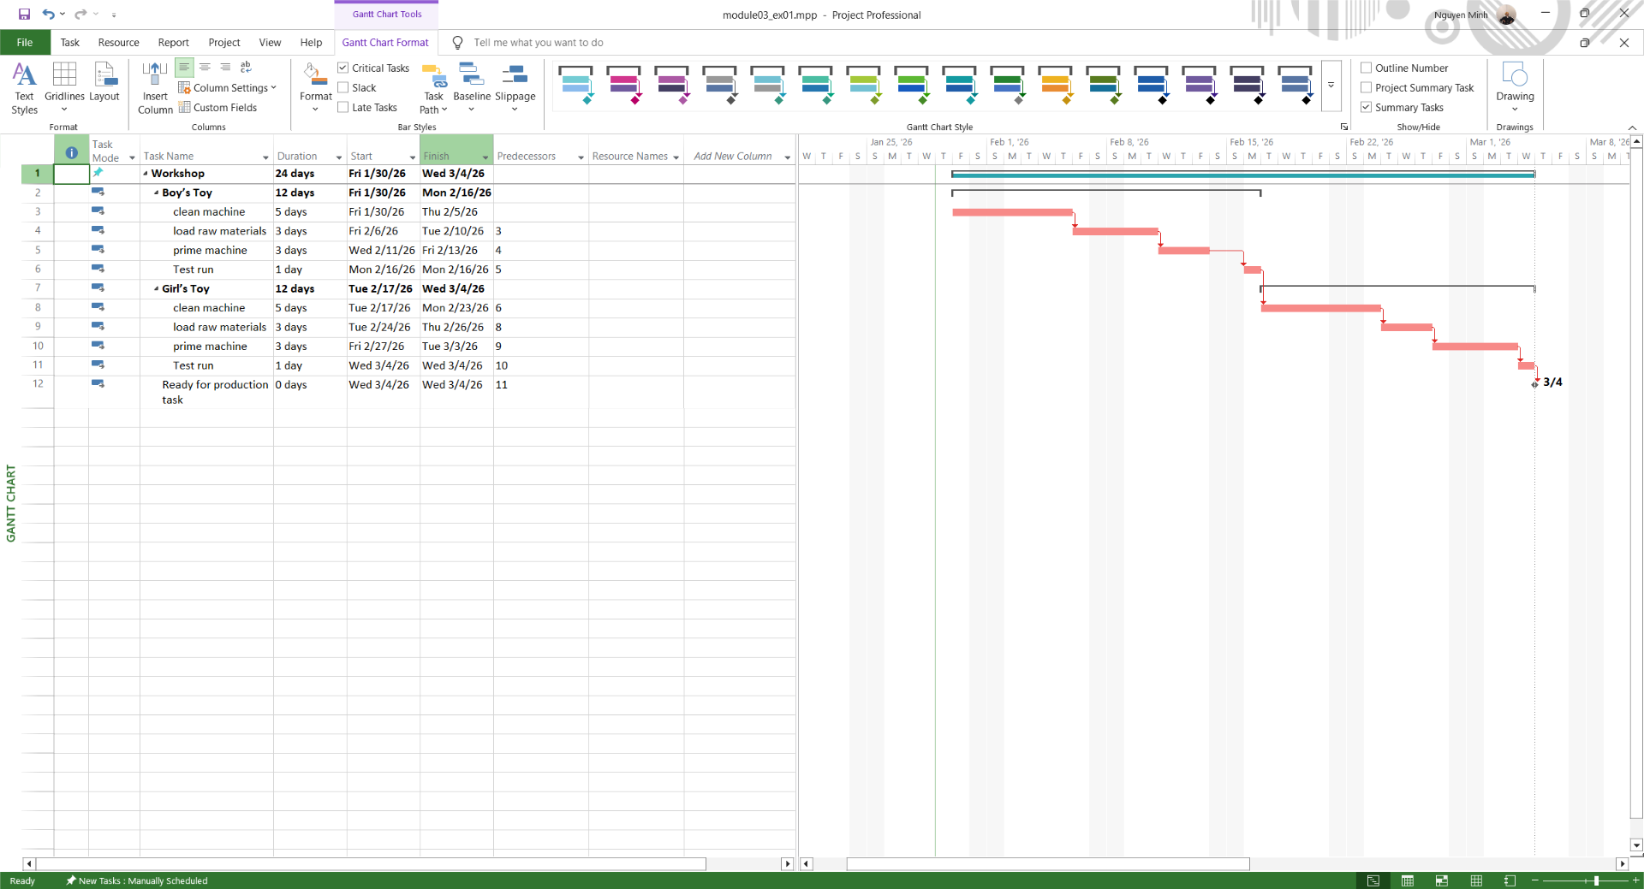

Total Slack

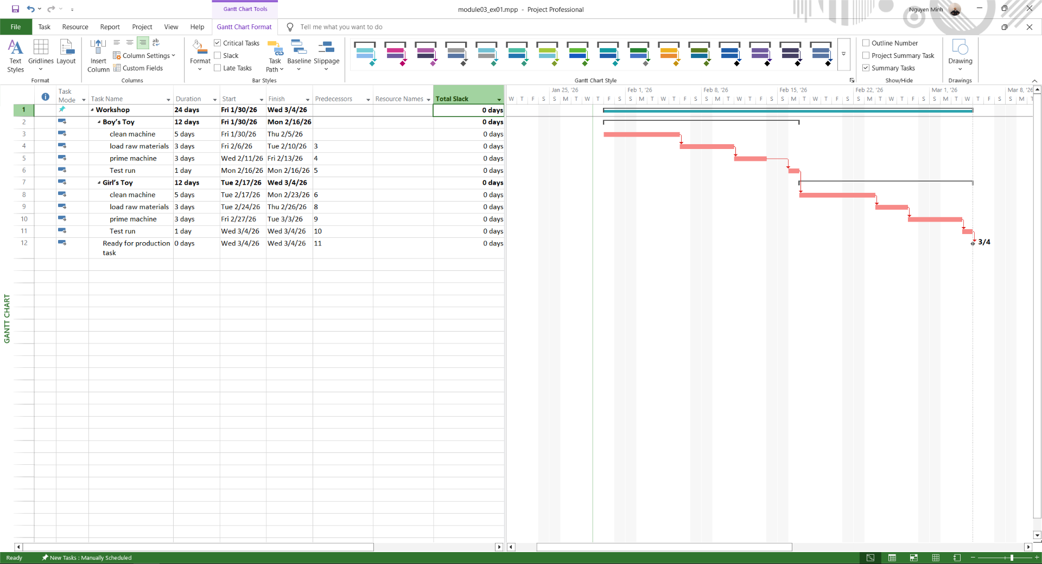

## Exercise 2:

## Exercise 3: